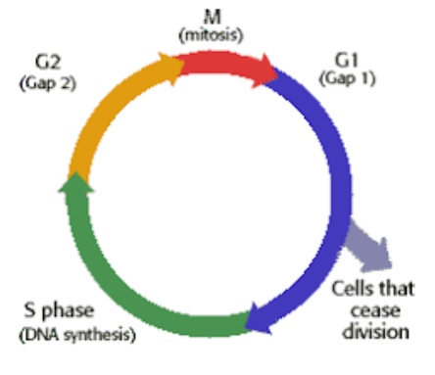

MITOSIS
NAME: ___________
BLOCK: _______
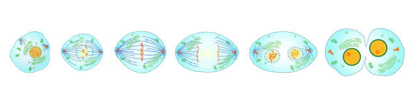
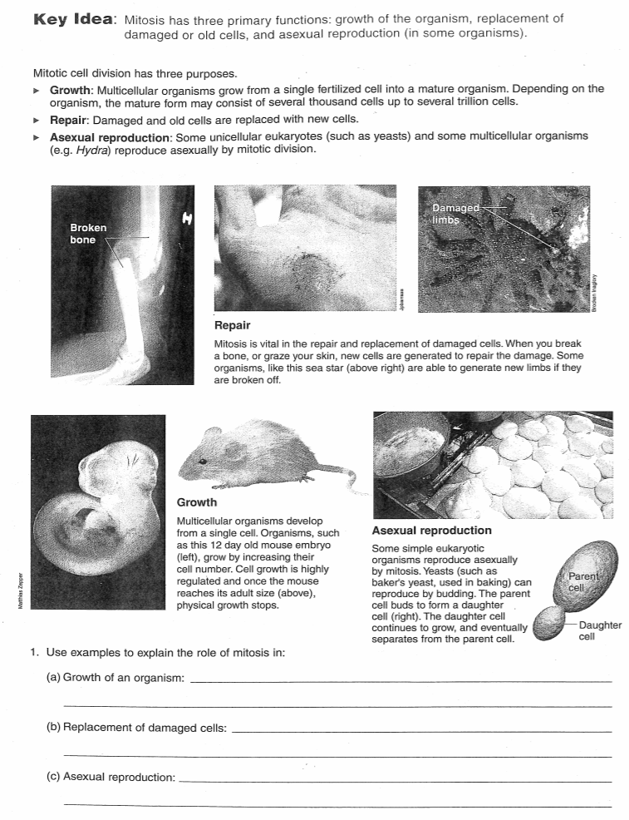

VIDEO NOTES - MITOSIS
https://www.youtube.com/watch?v=f-ldPgEfAHI&t=11s

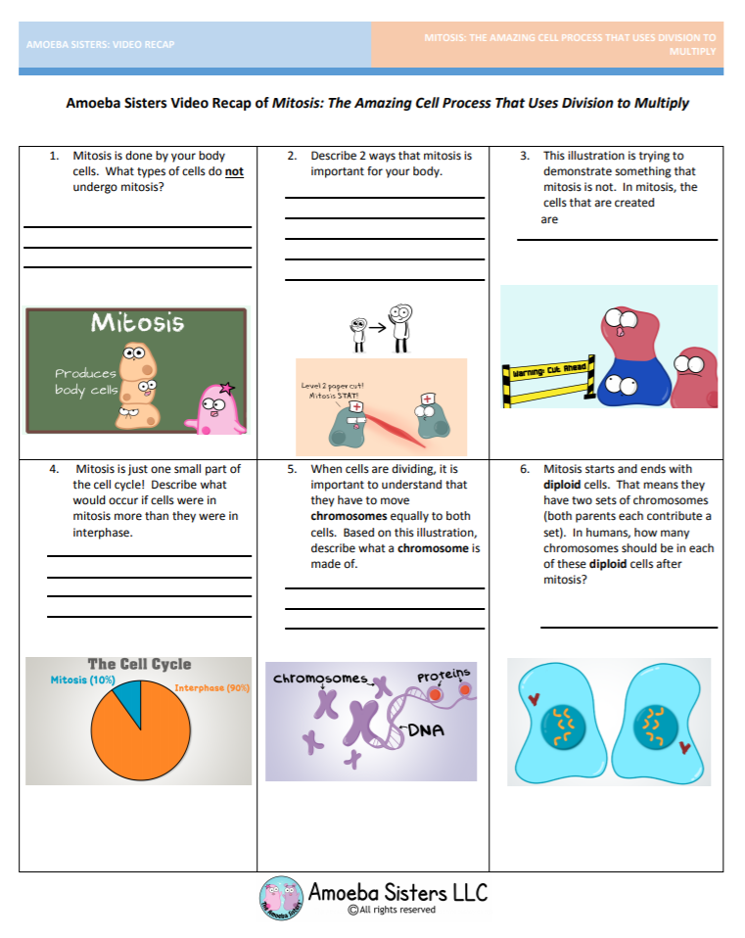

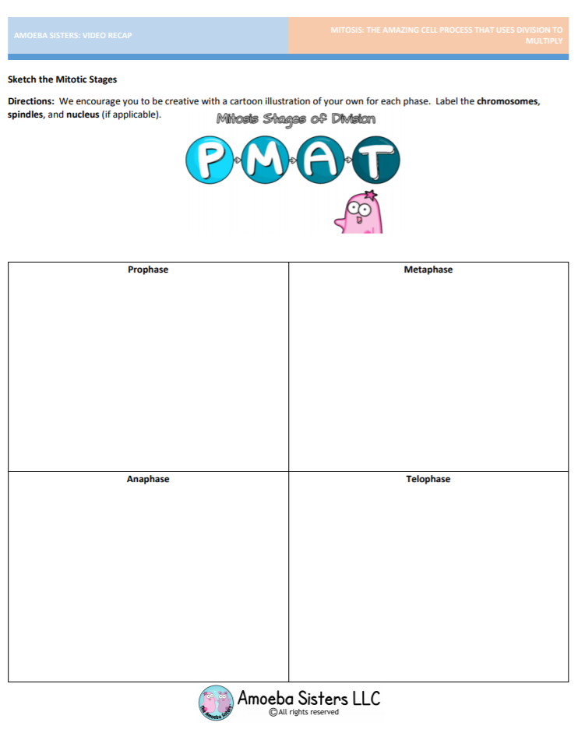

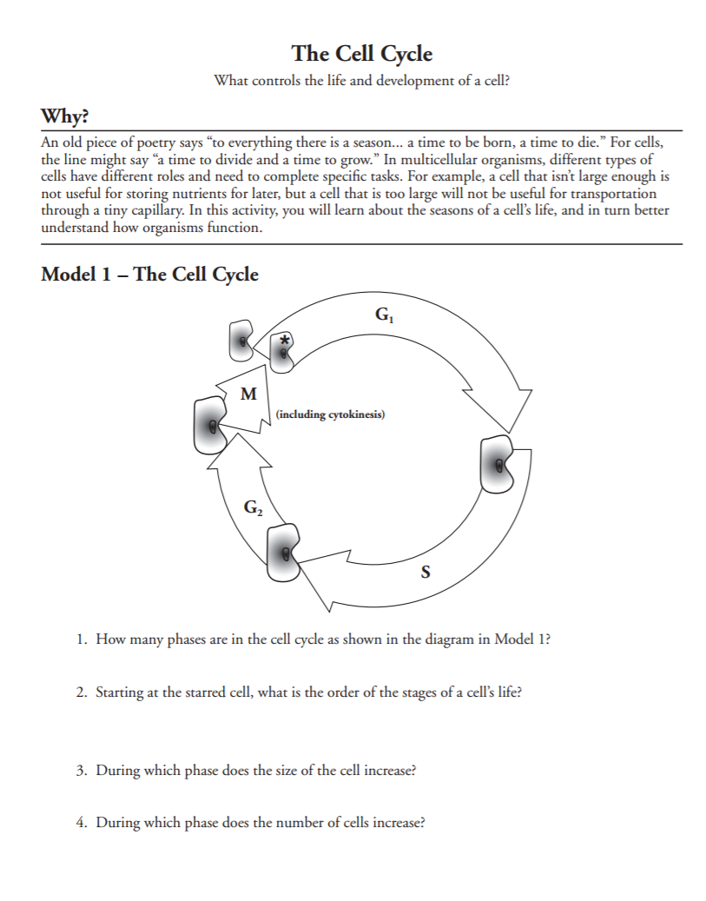

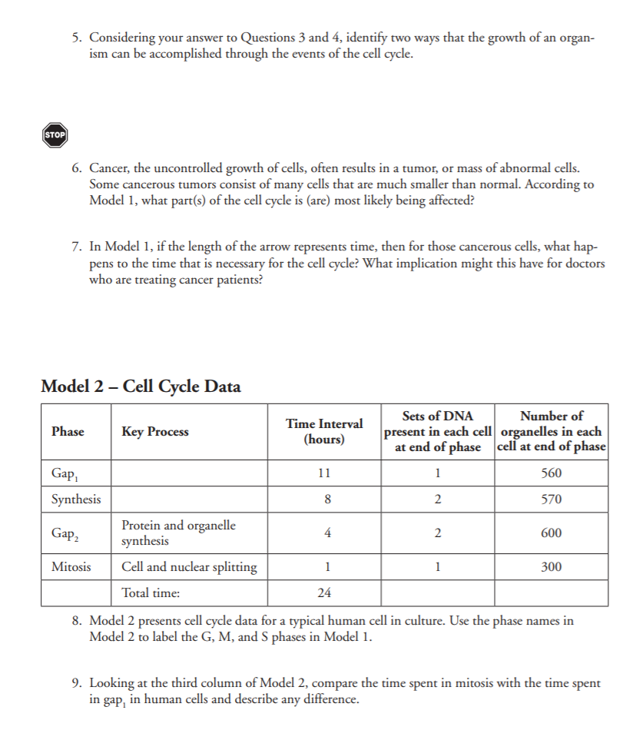

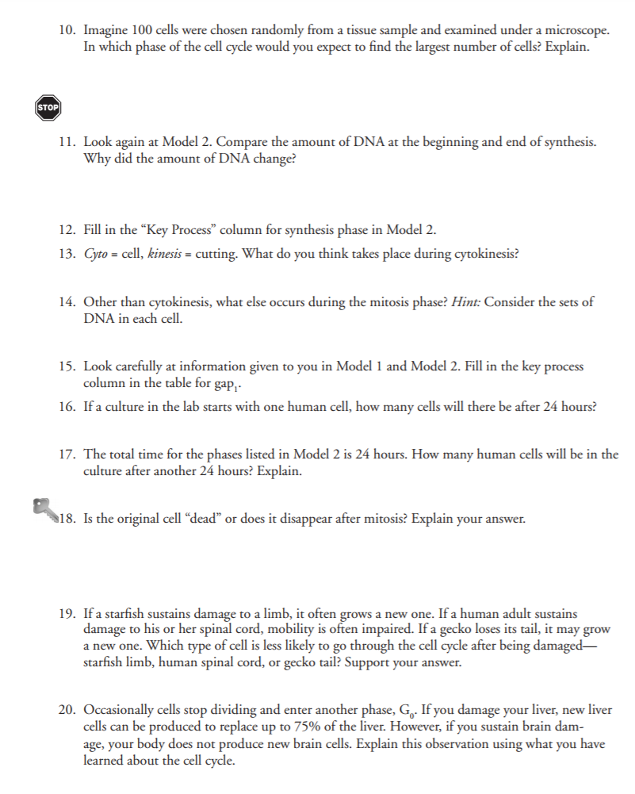

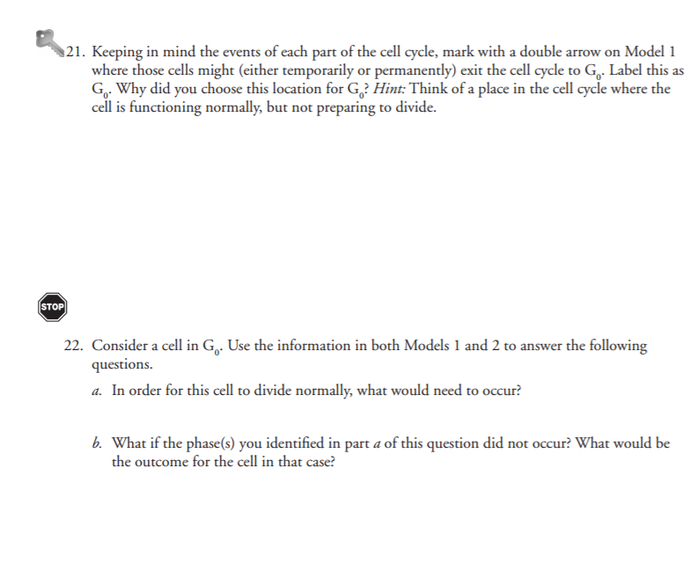

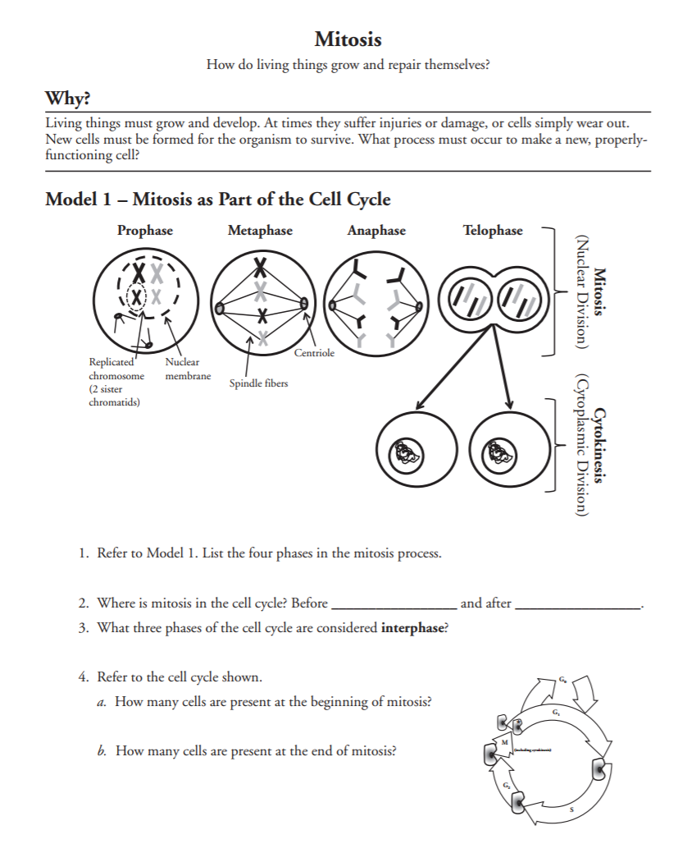

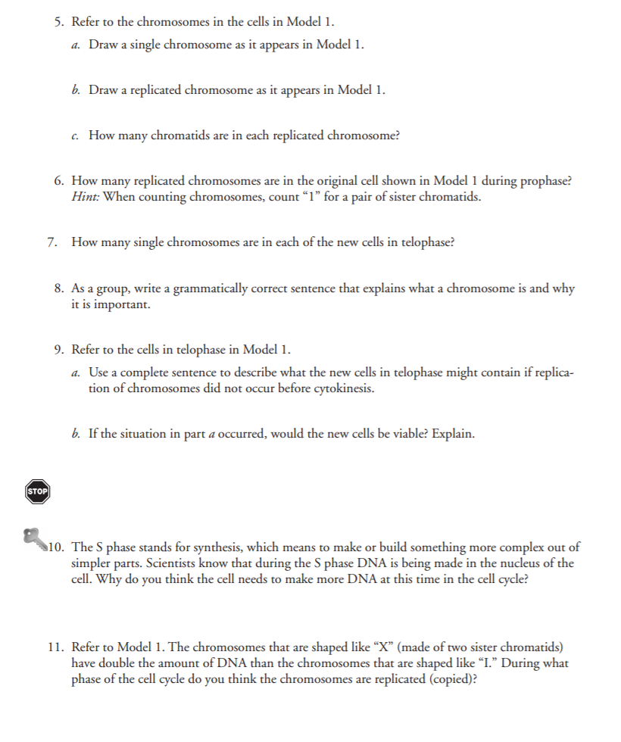

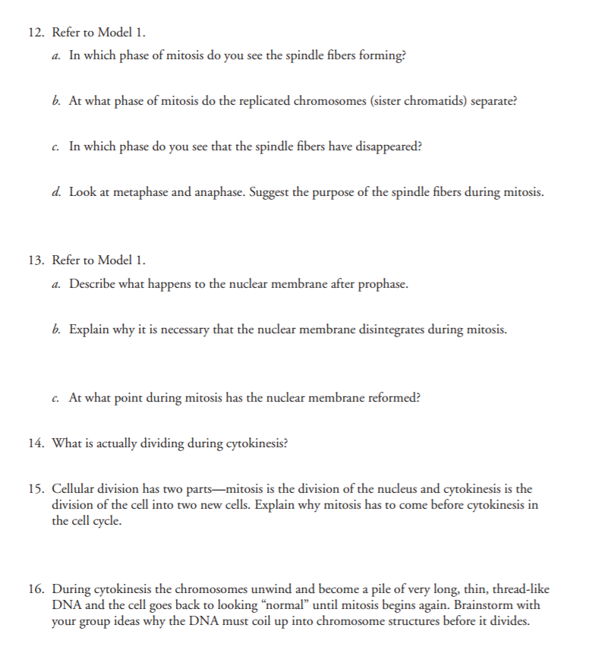

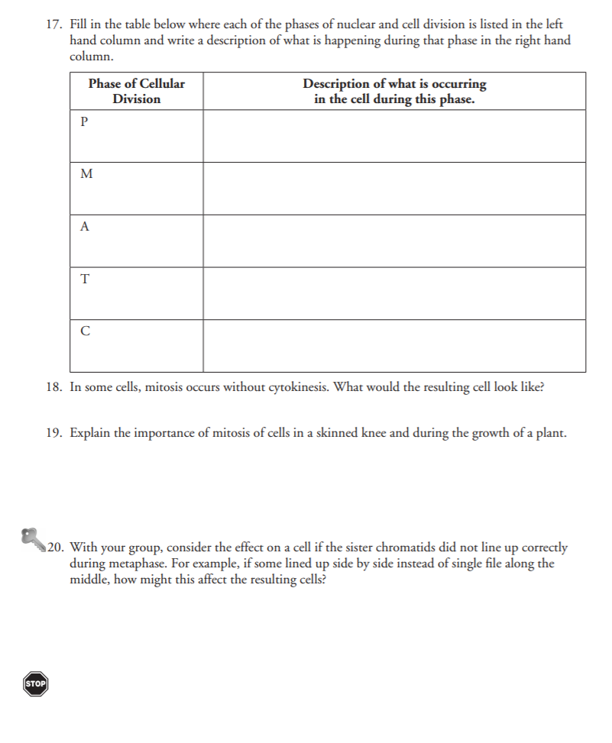

VIDEO NOTES-MITOSIS
https://www.youtube.com/watch?v=_QQixQYh4Ac&list=PLb3m_5kPlQwOn78c2uHdyFbXn8RHPZAYK&index=4

- PMAT stands for:
P ____________________________
M ____________________________
A ____________________________
T ____________________________

- Describe the steps of mitosis:
Interphase:

Prophase:

Metaphase:

Anaphase:

Telophase:

- Mitosis clues:
P ____________________________
M ____________________________
A ____________________________
T ____________________________

- Generally speaking, what is cancer?

Online Onion Root Tip Lab

Purpose:
In this activity, you will be presented with cells from the tip of an onion root. You will classify each cell based on what phase it is in. At the end you will count up the cells found in each phase and use those numbers to predict how much time a dividing cell spends in each phase. You can base your calculation on a total cell cycle of 24 hours.

Go to the following website:

http://www.biology.arizona.edu/Cell_bio/activities/cell_cycle/cell_cycle.html

Prelab questions:

- Why are onion root tips good for studying the cell cycle?

- How are the onion root tip cells prepared?

- What does it mean to say that the cell cycle is continuous?

Click next and briefly describe each phase of mitosis and include a diagram.

Phase | Description | Picture
Interphase

Prophase

Metaphase

Anaphase

Telophase

Click next and read the assignment. Click next again and look at the cell on the screen. Click on the phase in which this cell belongs. Follow the prompts until you have classified all 36 cells in the activity.

Fill in the table below and calculate the percentage of cells in each phase, and enter those values on the bottom row of the table.

 | Interphase | Prophase | Metaphase | Anaphase | Telophase | Total
# of Cells in Phase |  |  |  |  |  | 36
Percent of Cells in Phase |  |  |  |  |  | 100%

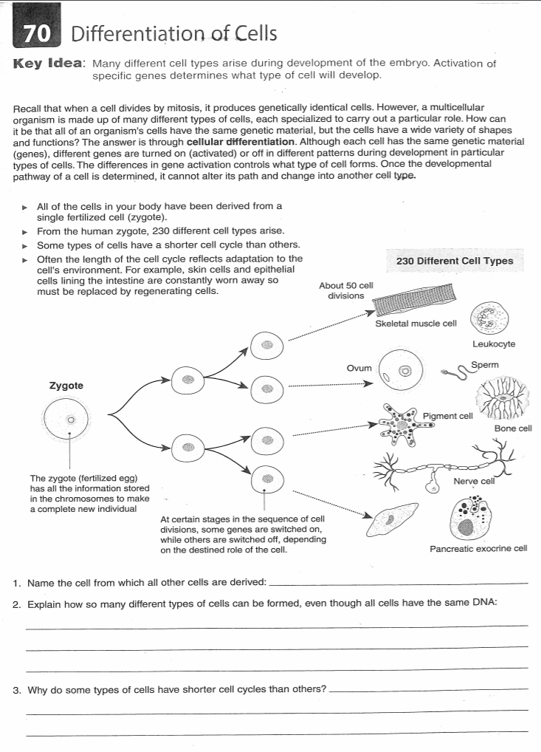
https://www.cellsalive.com/cell_cycle.htm
Scroll down and read “Events during Mitosis”
Click “Start Animation” and complete worksheet.

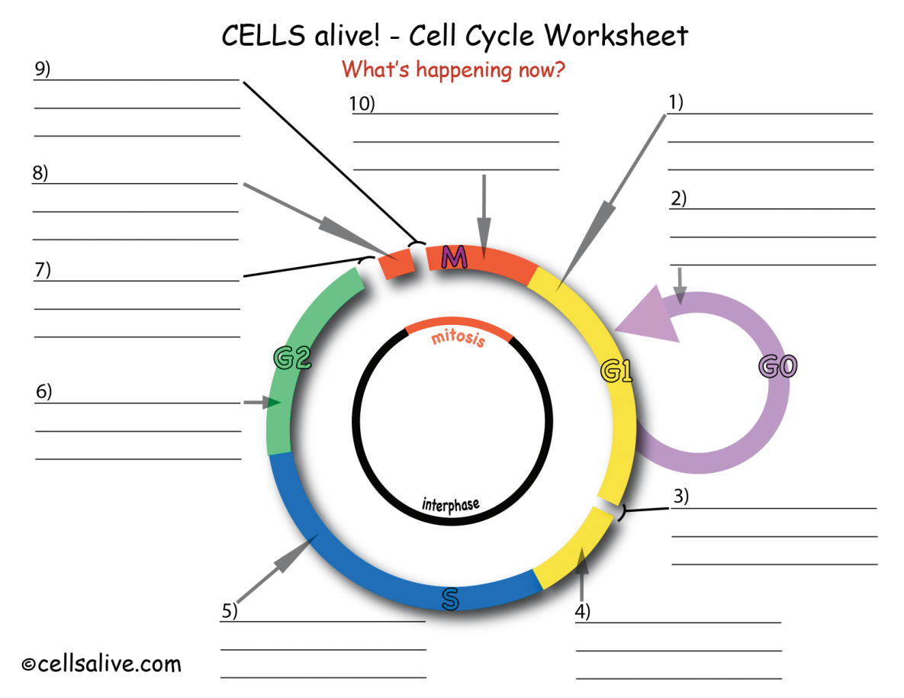

https://www.cellsalive.com/mitosis.htm
Scroll down and read “Events during Mitosis”
Click “Start Animation” and complete worksheet.
