PHOTOSYNTHESIS
Name ____________
Block _________

STRUCTURE OF A LEAF
https://www.youtube.com/watch?v=co0JdqUlycg
- Plants make food through ____________________

- A leaf is a plant’s ____________________ factory.

- The cells specialized for trapping light are found on top of the leaf. These cells are called ____________________ ____________________.

- They are packed full with ____________________. That’s why the top side of the leaf is ____________________ than the bottom side.

- Most cells have a ____________________ surface area so they can trap as much light as possible.

- The bottom of the leaf has pores called ____________________ which allow carbon dioxide to enter the leaf.

- These stomata are controlled by sausage shaped cells called ____________________ ____________________.

- Carbon dioxide enters the leaf through the stomata and make their way through the ____________________ ___________________ to the palisade layer for photosynthesis.

- Leaves are ____________________ so carbon dioxide doesn’t have too far to travel.

- Water comes up through the roots and enters the leaf through ____________________ ____________________ which contain a hollow tube called a ____________________.

- The vascular bundles spread out to form ____________________ that spread water throughout the cell.

- Above the palisade layer and below the spongy mesophyll are ____________________ ____________________ that produce a ____________________ ____________________.

- The cuticle ____________________ up the leaf.

- Label the parts of the leaf:

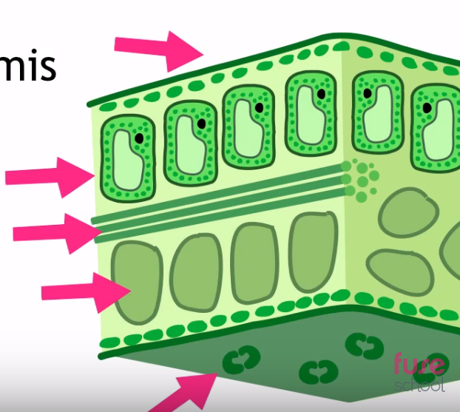

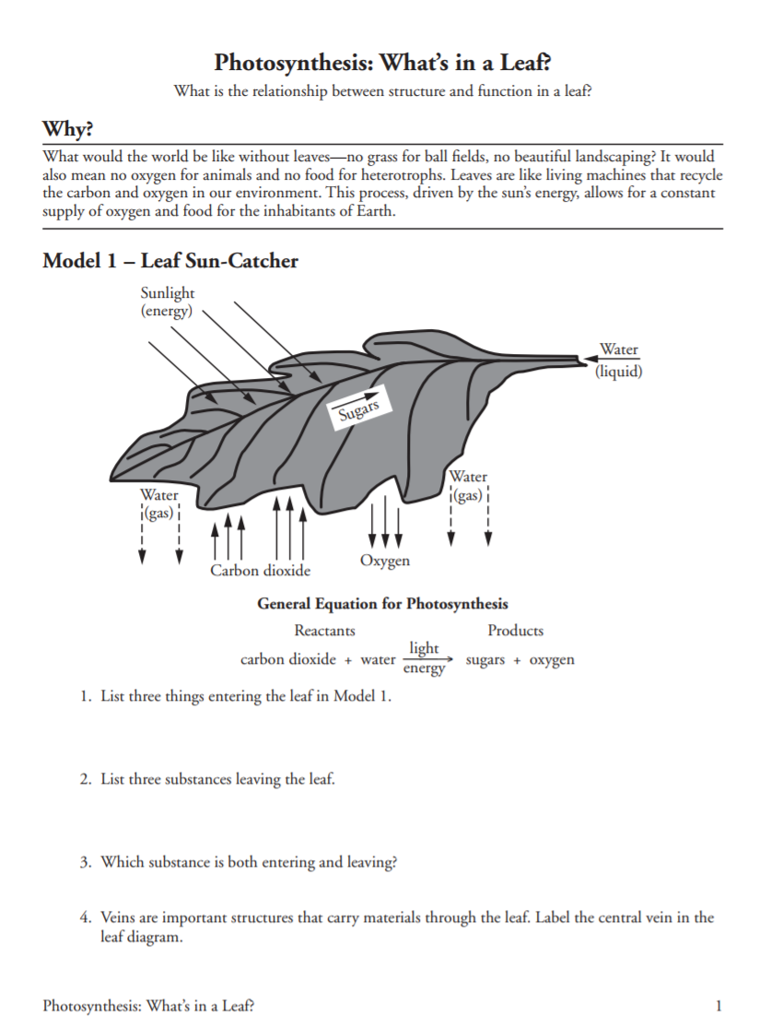
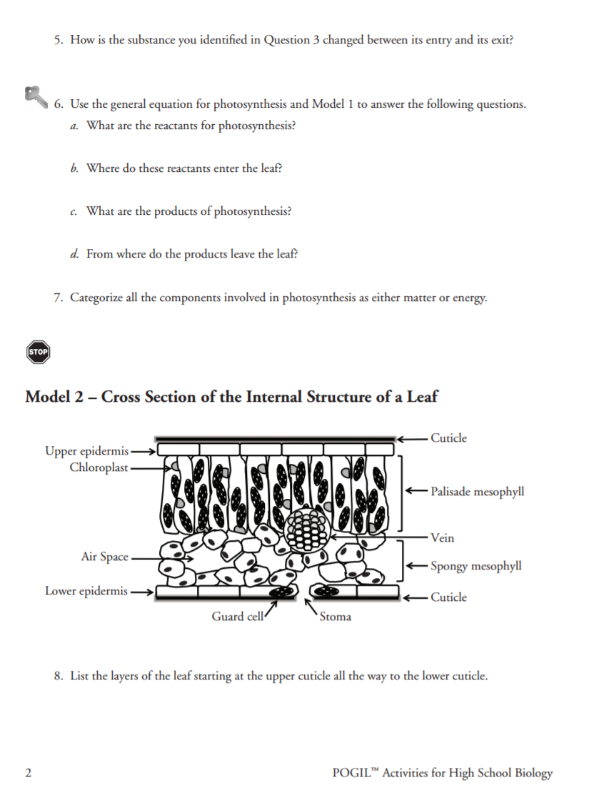
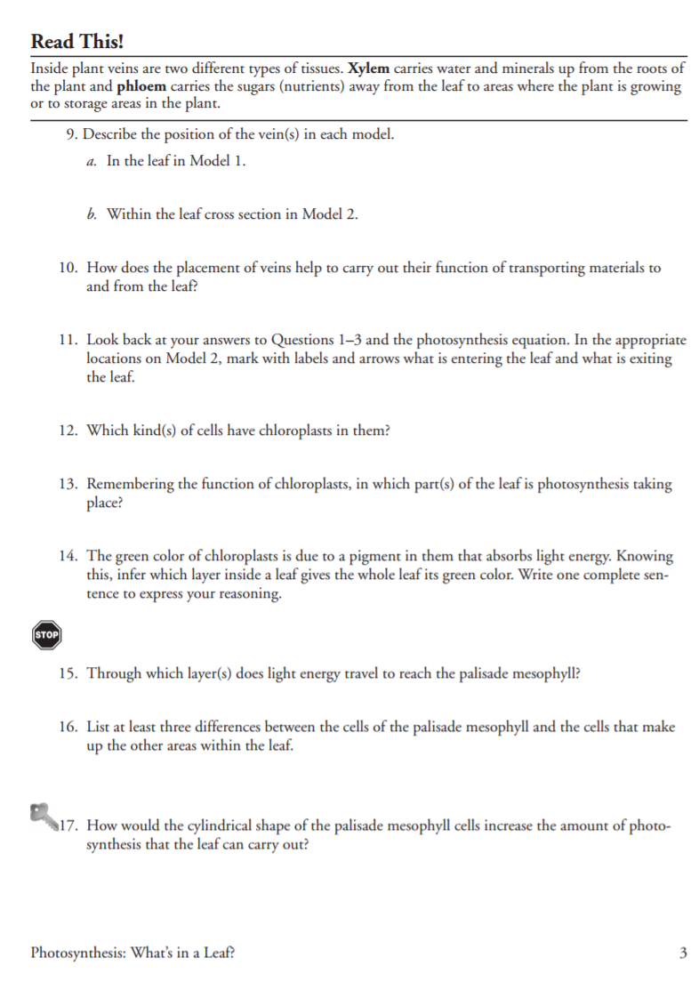

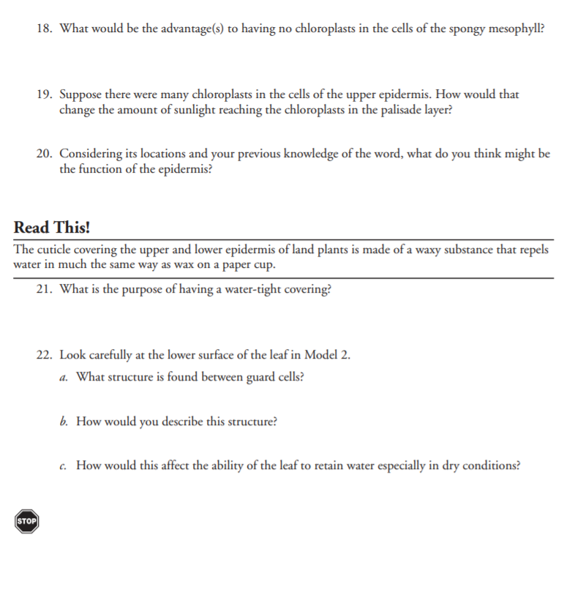

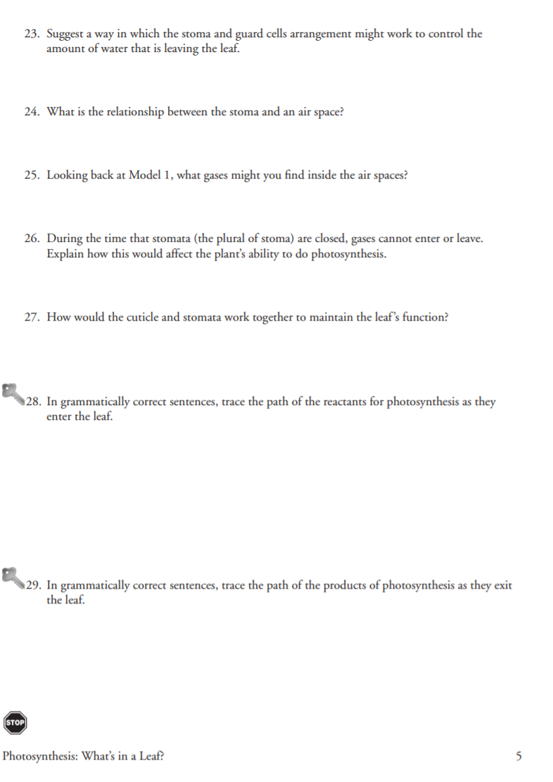

Paper Chromatography Lab

Pigments in the chloroplasts absorb light energy during the process of photosynthesis. The light is converted to glucose, a sugar (chemical energy). Chlorophyll a and chlorophyll b absorb light in the blue and violet range. Other pigments such as carotenes and xanthophylls absorb light in the orange, red and yellow range.

Chromatography is a method used to separate different kinds of molecules from each other based on size and solubility in a given solvent. Smaller, more soluble molecules will move faster and further than large less soluble molecules.

In this lab, paper chromatography will be used to separate the photosynthetic pigments present in spinach leaves.

Procedure:
- Obtain a piece of chromatography paper. ONLY TOUCH THE PAPER BY THE EDGES! The oils in your fingers will damage the paper.
- Make a pointed end in the chromatography paper by snipping the edges off one end
- Measure 3cm from the pointed end and draw a light pencil line horizontally
- Lay the spinach leaf across the line
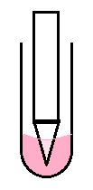
- Rub the penny across the spinach to in the direction of the line to cover the line with pigment from the spinach
- Add a small amount of chromatography solvent to a test tube
  - Caution when handling solvents this solvent is flammable
- Place the Chromatography paper into the test tube point down. The point should be touching the solvent, but the pencil line should be above the solvent.
- Watch the solvent move up the paper, when the solvent is close to the top remove the paper from the test tube and allow it to air dry
- Tape the strip to a piece of paper or draw it on the paper to the left and label the four bands of pigment
  - Yellow/Orange band is the carotenes
  - Yellow near the bottom is the xanthophylls
  - Below that is chlorophyll a and chlorophyll b. They are both green, but different shades.
Questions:
1. Sketch your results to the right:

2. Why is it beneficial to have pigments that absorb different wavelengths of light rather than only one color?

3. List the pigments in order from least to greatest solubility.

4. Do you think this would be true for all solvents? Hint You can try this by running the same experiment in H2O

Photosynthesis Demonstration
Purpose:
To show that plants use carbon dioxide (CO₂) from their environments in the process of photosynthesis
Background:
- Green plants use sunlight, carbon dioxide and water to make glucose (C ₆ H ₁₂ O ₆).
- To release energy, the glucose must be converted into ATP by means of cellular respiration.
- The waste products of cellular respiration are CO₂ and H₂O.
- CO2 dissolves in water to form a weak acid called Carbonic Acid.
- An acid-base indicator (bromothymol blue) can be used to indicate the presence of CO2 in the water.
How it works
- Exhaled air contains roughly 18% Oxygen, 78% Nitrogen and 4% Carbon Dioxide.
- Bromothymol blue changes colors when in the presence of an acid or base.
- Since exhaled air is partly composed of Carbon Dioxide, the CO2 combines with the water, forming Carbonic Acid (H2CO3)
- Carbonic Acid, being slightly acidic, turns the color of the Bromothymol blue solution yellow.
Photosynthesis
- Photosynthesis uses sunlight, carbon dioxide and water to form glucose and oxygen.
- Elodea is a water-dwelling plant that uses photosynthesis to remove carbon dioxide from water. Since carbon dioxide makes water acidic, the process of removing the acid decreases the acidity of the water.
- Once there is no more acid component to the solution, the bromothymol blue turns back to its original blue state.
Procedure
- Experimental test tube:
  - Fill a test tube 2/3 of the way with water. Add bromothymol blue solution.
  - Using a straw, blow bubbles into the water. (the solution should turn yellow.)
  - Put a sprig of elodea in the test tube.
  - Cover with parafilm and let sit overnight.
- Control test tube:
  - Fill a test tube 2/3 of the way with water. Add bromothymol blue solution.
  - Using a straw, blow bubbles into the water. (the solution should turn yellow.)
  - Put a sprig of elodea in the test tube.
  - Cover with parafilm.
  - Wrap entire test tube in aluminum foil and let sit overnight.
Questions:
Why should the bromothymol blue solution turn yellow after you blow bubbles into it?

Why did we wrap the control test tube in aluminum foil? (hint: what does the foil prevent from entering the test tube?)

Results:
What happened in the experimental test tube?

What happened in the control test tube?

Conclusion:
Explain your observations in terms of photosynthesis.
Chlorophyll Graphing Activity

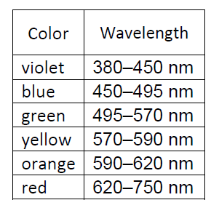

- Color the graph above using the chart on the right.

- What color is least absorbed by chlorophyll a?
- What color is least absorbed by chlorophyll b?
- What color is most absorbed by chlorophyll a?
- What color is most absorbed by chlorophyll b?
- Beta carotene has its highest absorbance between 400nm and 550nm. It has zero absorbance under 400nm and over 550nm.
  - Graph the absorbance of beta carotene on the graph with chlorophyll a and chlorophyll b. Make sure you label the graph.
  - What color(s) is plant tissue that is high in beta carotene?
  - What color(s) does beta carotene absorb?
- What foods are high in beta carotene (name 3)?
- Do you think that some plant pigments may absorb colors we cannot see? Explain
The Amazing Process of Photosynthesis
https://www.youtube.com/watch?v=pFaBpVoQD4E

Watch the video and take notes during the summary:

- Green plants can make their own food by ____________________

- Roots absorb ____________________ and end it to the leaves.

- Leaves absorb ____________________ through pores called stomata.

- The water and carbon dioxide are absorbed by the ____________________.

- In the presence of chlorophyll and sunlight, chloroplasts synthesize ____________________ and ____________________.

- The ____________________ diffuses out through the stomata.

- The ____________________ is transferred through specialized tubes to aid the plant in growth.

Photosynthesis in More Detail
The Light Dependent Reaction and the Calvin Cycle
https://www.youtube.com/watch?v=uJlc8QLawfA

- Chloroplasts are filled with a green pigment called ___________________

- Label the parts of the chloroplast below….

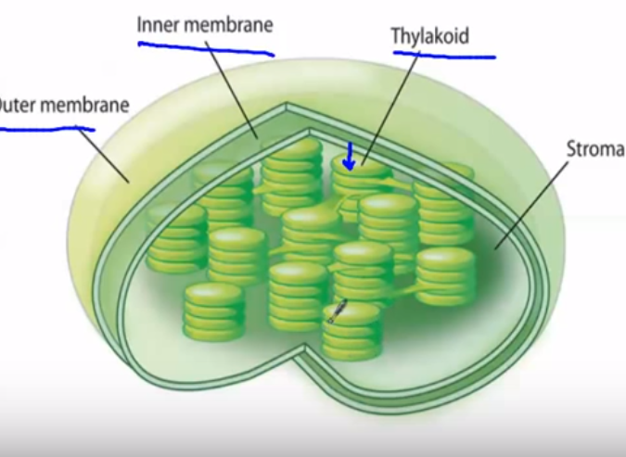

- Each coin in the stack is called a ____________________

- The ____________________ is the space between the inner membrane and the thylakoid.

- The equation for photosynthesis is:

_____________+_____________+_____________--> _____________+_____________

- The raw material for photosynthesis are
____________________, ____________________, and ____________________

- The products of photosynthesis are
____________________ and ____________________

Part 1-The Light Reaction
- In the first part of photosynthesis, sunlight travels from the sun and strikes the ____________________
- Water is transported into the ____________________.

- The energy from the light will ____________________ the water. The oxygen atoms will pair up and make molecules of oxygen. This is the oxygen we breathe.

- The main reason this happens is so ____________________ is made. This energy is used in the second part of photosynthesis.

Part 2 – The Calvin Cycle

- In the Calvin Cycle, energy allows ____________________ atoms to react with ____________________ ____________________to make glucose (C₆H₁₂O₆)

- The glucose moves to the phloem vessels which sends it to the rest of the plant.

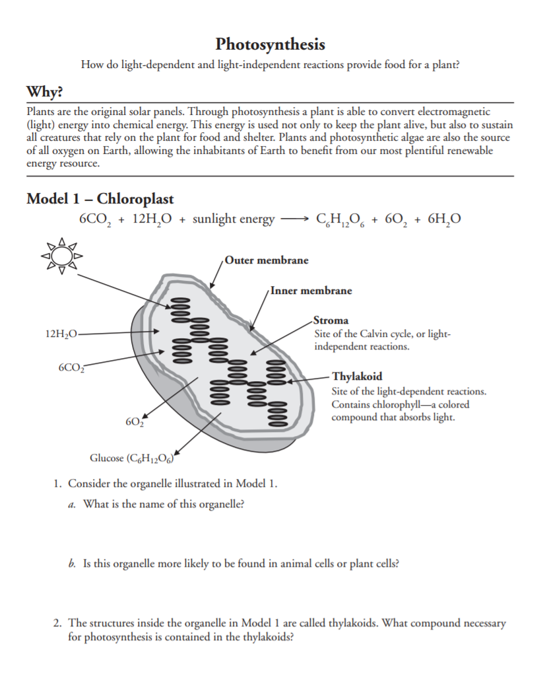

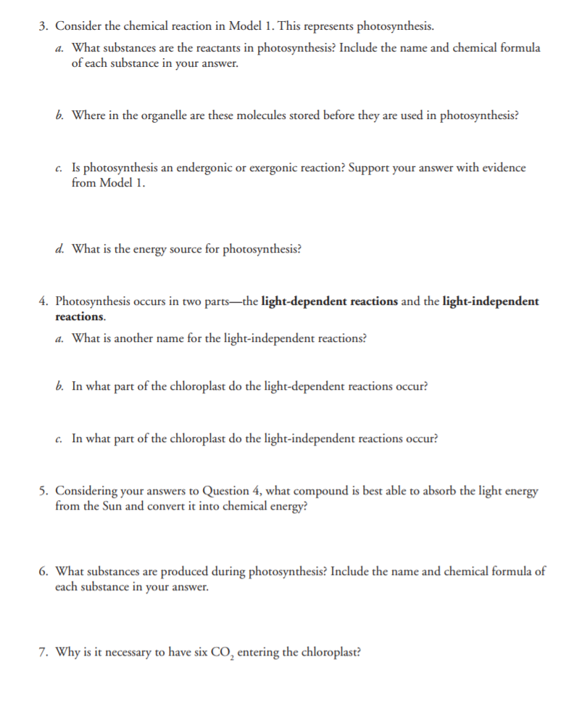

Read This!_________________________________________________________________
If you've ever stayed out too long in the sun and gotten a sunburn, you're probably well aware of the sun's immense energy. Unfortunately, the human body can't make much use of solar energy, aside from producing a little Vitamin D (a vitamin synthesized in the skin in the presence of sunlight).
Plants, on the other hand, are experts at capturing light energy and using it to make sugars through a process called photosynthesis. This process begins with the absorption of light by specialized organic molecules, called pigments, that are found in the chloroplasts of plant cells.
_______________________________________________________________________________

- The absorption of light by organic molecules called ________________ begins the process of photosynthesis.

- These pigments are found in the ____________________ of plant cells.

Model 2-Photosynthesis
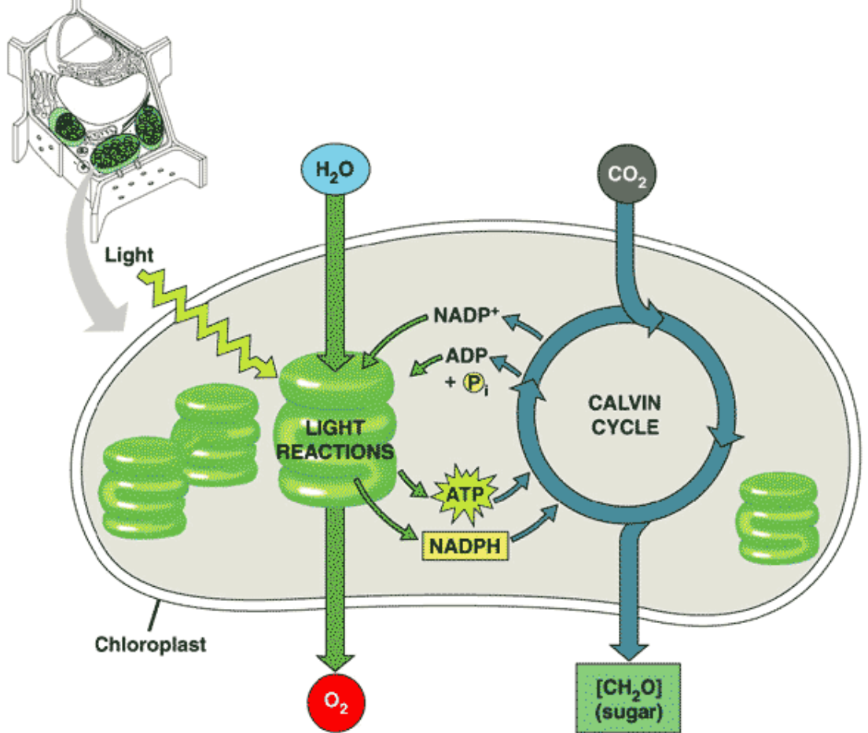
- Which organelle is pictured in Model 2?

- What process takes place in Model 2?

- Looking back at Model 1, in which structures within the chloroplast do the light-dependent reactions take place?

- Look at Model 2, what two things are required from the environment for the light reaction to occur?

- What product of the light-dependent reactions is released into the environment?

- What two molecules are produced by the light-dependent reaction and used in the Calvin Cycle?

- Look at Model 1, where in the chloroplast does the Calvin Cycle take place?

- What molecule is required from the environment for the Calvin Cycle to occur?

- What product of the Calvin Cycle is released from the chloroplast to be used by the plant?

- What two molecules are produced by the Calvin Cycle that are recycled back into the Light-Dependent Cycle?

