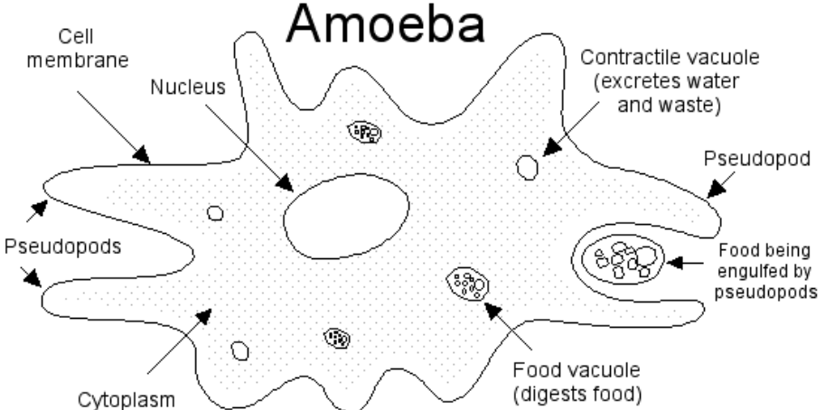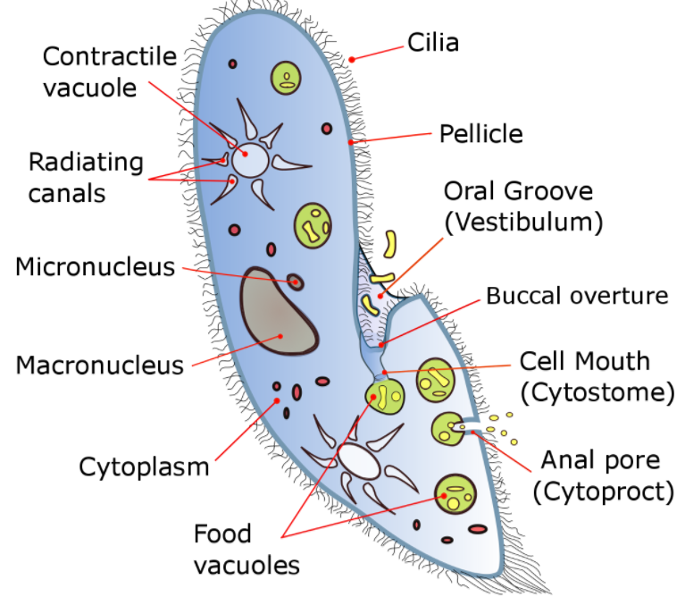

UNIT 15 – PROTISTS
NAME _____________
BLOCK _____________

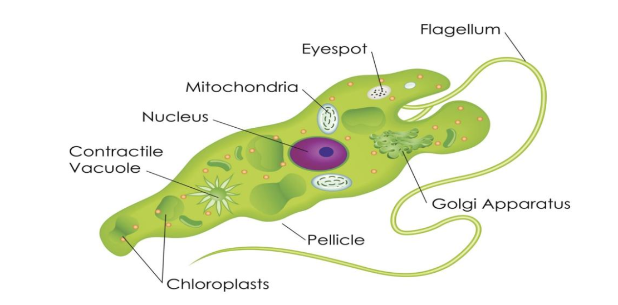
VIDEO NOTES
KINGDOM PROTISTA
https://www.youtube.com/watch?v=mNsFk2OZi3Q

What Are Protists?

In this exercise we will explore the Internet to learn about Protists, but first we need to understand where the Protists fit in the classification system.

Easier said than done!

We have a problem in taxonomy today; the classification of biological organisms is anything but cut-and-dried (or carved in stone)! A certain amount of chaos now reigns and will continue to reign until the next great synthesis occurs among biologists. This means that you can expect a certain amount of disagreement between what textbooks and the various sites on the web will tell you about classification.

Right now you are familiar with two current models of classification:

A living thing is either a Prokaryote or Eukaryote.
A living thing is in one of the following kingdoms: Monera, Protista, Fungi, Plantae or Animalia.

We tend to overlay the two as follows:
Prokaryote = Monera
Eukaryote = Protista, Fungi, Animalia and Plantae.

But biologists have many other schemes in the works. One new classification scheme classifies all living things into three “Domains”.

Q. What are the names of the three domains?

A.

Q. Why are the prokaryotes divided into two different domains in this classification model?

A.

Q. How are the Archaea different from the Bacteria?

A.

Q. Which domain are the Protista in?

A.

Some biologists have married the three domain system and the five kingdom system and come up with a six kingdom system (shown below). Note: Archaeabacteria is the old name for Archaea.

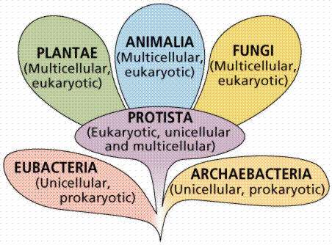
Image from W.H. Freeman and Sinauer Associates, used by permission

Within this system, the Protists are the most difficult kingdom to classify!

It is certain that Protists belong in the domain Eukarya, but what characterizes Protists? The Kingdom Protista has become a “dumping ground” for organisms that don’t fit into the other three kingdoms. They are always eukaryotes, but after that just about anything goes. Protist classification is still in such flux that many of the group names are just not worth learning. In fact, some biologists predict that it is likely the Protista will be divided into 10-12 kingdoms in the coming years!

Q. What are the general characteristics of Protista?

A.

Now let’s move on to some animal-like protists; the Protozoa
Rhizopods

One Protozoan group we shall examine is called Rhizopoda or Sarcodina.

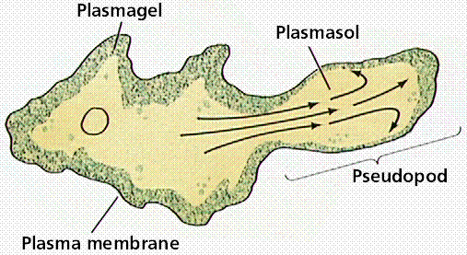

A typical rhizopod is the ferocious predator Amoeba proteus. The interesting thing about Amoeba is that their cytoplasm can exist in two states: the liquid “sol” endoplasm and the semi-solid “gel” ectoplasm. The two consistencies work together to help the Amoeba move and feed.

So how do they move?

A quick link explaining how they move.

Q. What is a pseudopod?

A.

Q. How does an Amoeba survive harsh environmental conditions?

A.

The Amoeba seems like a harmless little guy, but some species are downright nasty!

Q. What are the symptoms of amoebic dysentery?

A.

Just for fun, check out the Amoeba Dance site.

The Amoeba
(modified from The Biology Corner – Worksheets and Lessons)

The amoeba is a protozoan. It belongs to Kingdom Protista. Protists are microscopic one-celled organism. The amoeba is an animal-like protist. It can move and consumes its food (consumer). The amoeba moves by stretching its cytoplasm. These are called pseudopods ("false foot"). The amoeba can change its shape. Amoebas live in ponds or puddles, and can even live inside people.

The pseudopods help an amoeba to eat. They surround the food and put it in a food vacuole. The food is digested while in the food vacuole.

Amoebas can cause disease. One disease caused by the amoeba is called Amoebic Dysentery. A person becomes infected by drinking unsanitary water. The amoeba upsets the person's digestive system and causes cramps and diarrhea.

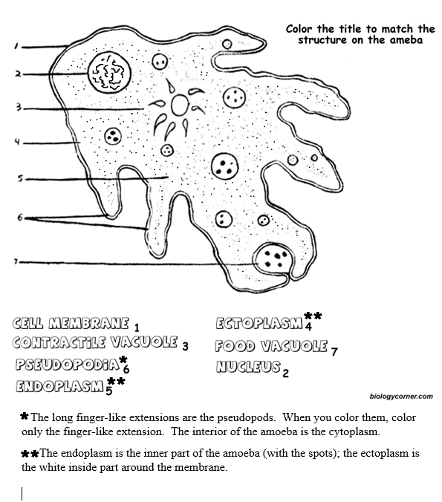

Here is another animal-like protists; the Protozoa
Ciliates

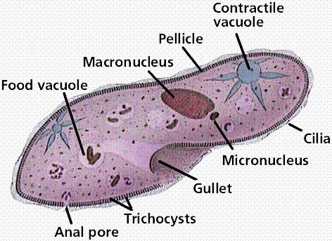
Ciliates are an example of animal-like Protists. They are covered with up to 17,000 cilia beating from 40 to 60 times a second in a coordinated fashion!

Cilia are used for locomotion. A movie of a moving paramecium!

The following link is a rather large site on Protista.

Scroll down until you find ciliates and answer the following questions:

Q. What is the difference between a macro- and a micro- nucleus?

A.

Q. How do ciliates deal with osmosis and the influx of excess water?

A.

Q. How do ciliates eat and excrete wastes?

A.

Q. What are trichocysts?

A.

The Paramecium
(modified from The Biology Corner – Worksheets and Lessons)

Paramecium is one-celled (unicellular) protozoans. They belong to Kingdom Protista. They live in quiet or stagnant ponds. They eat algal scum and other microorganisms. Small organisms eat them. They move by tiny hair-like projections called cilia. Color all cilia black.

The paramecium cannot change its shape. This is because it has a thick outer membrane called the pellicle. Color the pellicle light blue.

There are two types of nuclei (plural of nucleus). The large nucleus is called the macronucleus. It controls respiration, protein synthesis and digestion. Color the macronucleus red. The much smaller micronucleus is used only during reproduction, color the micronucleus yellow.

Contractile vacuoles are used in animal cells to remove the excess water. The contractile vacuole is shaped like a star - color the contractile vacuole green.

Paramecium is consumers. Food enters the paramecium through the mouth pore (color orange) and goes to the gullet (color blue). At the end of the gullet, food vacuoles are formed. Food vacuoles remain in the cytoplasm until the food is digested. Color all food vacuoles brown. Undigested food particles are eliminated through the anal pore (color light green). The indented area where food enters the paramecium is referred to as the oral groove.

Just inside the pellicle are trichocysts. The paramecium can shoot tiny threads out of the cell to entangle a predator or to make themselves appear bigger. Color the trichocysts purple.

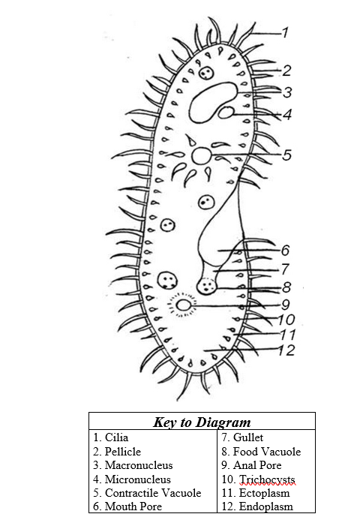

A well-known representative of the Plant-like Protists:
Euglenoids

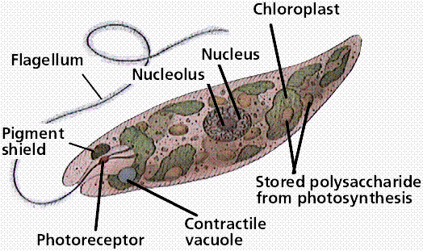
Euglena have flagella and a gullet like an animal cell. (heterotrophic injestion)

Euglena have chloroplasts like a plant cell (autotrophic photosynthesis)

And Euglena have been known to lose their chloroplasts, forcing them to absorb nutrients from their environment (Heterotrophic absorption)

Consequently, Euglenoids arguably can be classified as animal, plant and fungus!

Q. Two reasons the Eugleonoids are considered to be animal-like are:

A.

Q. What are three ways Euglenoids can eat?

A.

Q. How do Euglenoids move? Does their flagella indicate the front end or the back end of a euglena?

A.

Euglena wants to move towards the light for photosynthesis! Q. How does Euglena orient itself so it can move towards the light? Explain in your own words.

A.

Euglenoids keep their shape because of a pellicle. Q. Define pellicle.

A.

The Euglena
(modified from The Biology Corner – Worksheets and Lessons)

Euglena is one-celled (unicellular) organisms. They belong to Kingdom Protista. All Euglena have chloroplasts. Chloroplast allows Euglena to make their own food (they are producers). Euglena can also absorb food from their environment. Euglena lives in ponds or puddles.

Euglena move by a flagellum (plural ‚ flagella), which is a long whip-like structure that acts like a little motor. The flagellum is located on the front end, and twirls in such a way as to pull the cell through the water. Color the reservoir light blue and the flagellum black.

Chloroplasts use sunlight to make the Euglena’s food. They are rod-like structures throughout the cell. Color the chloroplasts green. Euglena has an eyespot at the front end. It detects light. This helps the Euglena find bright areas to gather sunlight to make their food. Color the eyespot red.

The Euglena has a stiff pellicle outside the cell membrane. It helps it keep its shape. The Euglena can also move like an inchworm. Color the pellicle blue.

In the center of the cell is the nucleus. It controls the cell’s activities. The nucleolus can be seen within the nucleus. Color the nucleus purple, and the nucleolus brown.

The interior of the cell contains a jelly-like fluid called cytoplasm. Color the cytoplasm yellow. Toward the back of the cell is a star-like structure. This is the contractile vacuole. It helps remove excess water. If it got too much water, the cell would explode. Color the contractile vacuole orange.

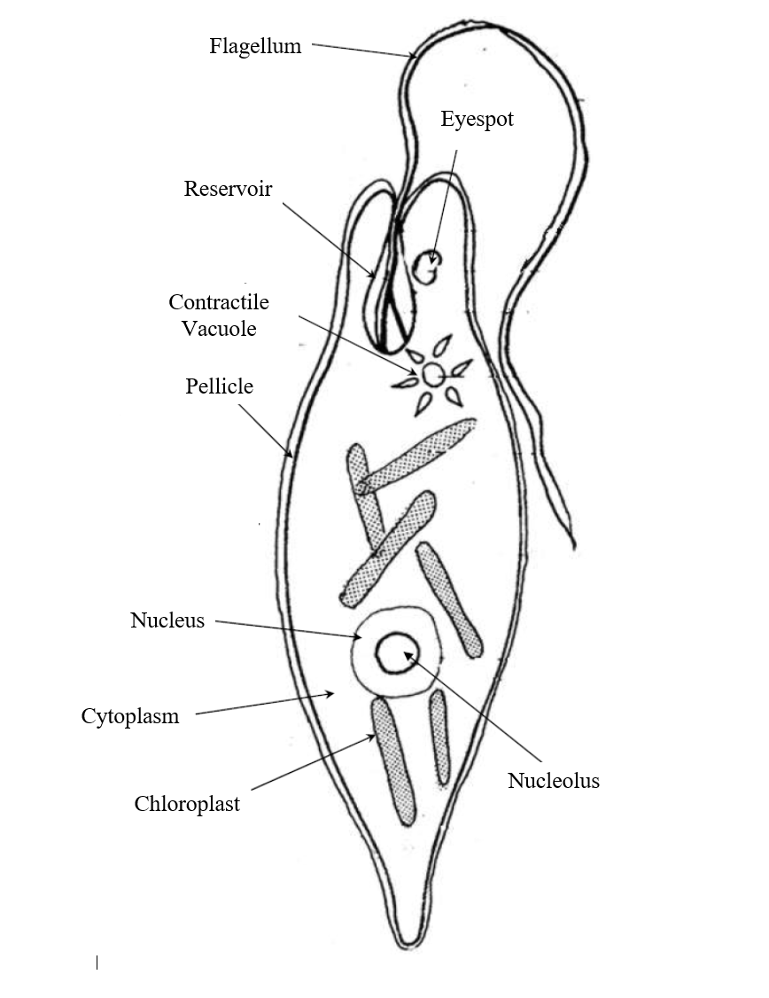
Sporozoans

Finally, let’s take a look at a not-so-nice group of Protozoans – the Sporozoans. These parasitic organisms cannot move on their own because they do not need to! They are passed from host to host in a constant disease cycle.

Q. Scroll down to the section on Sporozoans. Name two human diseases caused by Sporozoans:

A.

Q. A Sporozoan has a different life cycle from the disease-causing Amoeba you saw earlier. What is the major difference in life cycles?

PROTISTS: LIVE SPECIMEN LAB

Draw, label and color the following protists:

Ameba proteus
Phylum:

Description of organism:

Describe movement:

Autotrophic or Heterotrophic

Paramecium caudam
Phylum:

Description of organism:

Describe movement:

Autotrophic or Heterotrophic

Euglena agnac
Phylum:

Description of organism:

Describe movement:

Autotrophic or Heterotrophic

Stentor
Phylum:

Description of organism:

Describe movement:

Autotrophic or Heterotrophic

Volvox globator
Phylum:

Description of organism:

Describe movement:

Autotrophic or Heterotrophic

Spirogyra
Phylum:

Description of organism:

Describe movement:

Autotrophic or Heterotrophic

DO NOW QUESTIONS

