CELLULAR RESPIRATION
AND
PHOTOSYNTHESIS

NAME ________________
BLOCK ____________

VIDEO – CELLULAR RESPIRATION
https://www.youtube.com/watch?v=4Eo7JtRA7lg

- __________ stands for adenosine triphosphate.

- ATP contains __________ phosphates.

- When the third phosphate is broken off, it releases a great deal of __________.

- The adenosine _____phosphate is then converted to adenosine _____phosphate.

- ATP can be made efficiently by _________________ _________________ _________________

CELLULAR RESPIRATION

C₆H₁₂O₆ + 6 O₂ 6 CO₂ + 6 H₂O + ATP Energy

__________________ __________________

PHOTOSYNTHESIS
_{LIGHT}
6 CO₂ + 6 H₂O C₆H₁₂O₆ + 6 O₂
__________________ __________________

- When comparing cellular respiration and photosynthesis, the reactants and products are just on ____________________ sides.
CELLULAR RESPIRATION-STEP 1
- The first step of cellular respiration is ____________________

- This process takes place in the ____________________.

- This process does not require ____________________

- In this step, glucose is converted to ____________________
- In this step, 2 ____________ molecules are produced and ____________ NADH molecules are produced.
CELLULAR RESPIRATION-STEP 2

- The second step of cellular respiration is ____________________.

- This process takes place in the ____________________.

- This process does not require ____________________.

- In this step, pyruvate is oxidized into 2 __________, 6 __________ and 2 __________

CELLULAR RESPIRATION-STEP 3

- The third step of cellular respiration is the ____________________ ____________________ ____________________.

- This process takes place in the ____________________.

- This process requires ____________________

- In this step, ____________________ are transferred from NADH and FADH₂ to several electron carriers to create a proton (H⁺)gradient.

- These protons power an enzyme called ATP synthase to make ____________________.

- In the end ____________________ combines with 2 protons (H⁺) to make ____________________

- The Electron Transport Chain makes lots of ____________________.

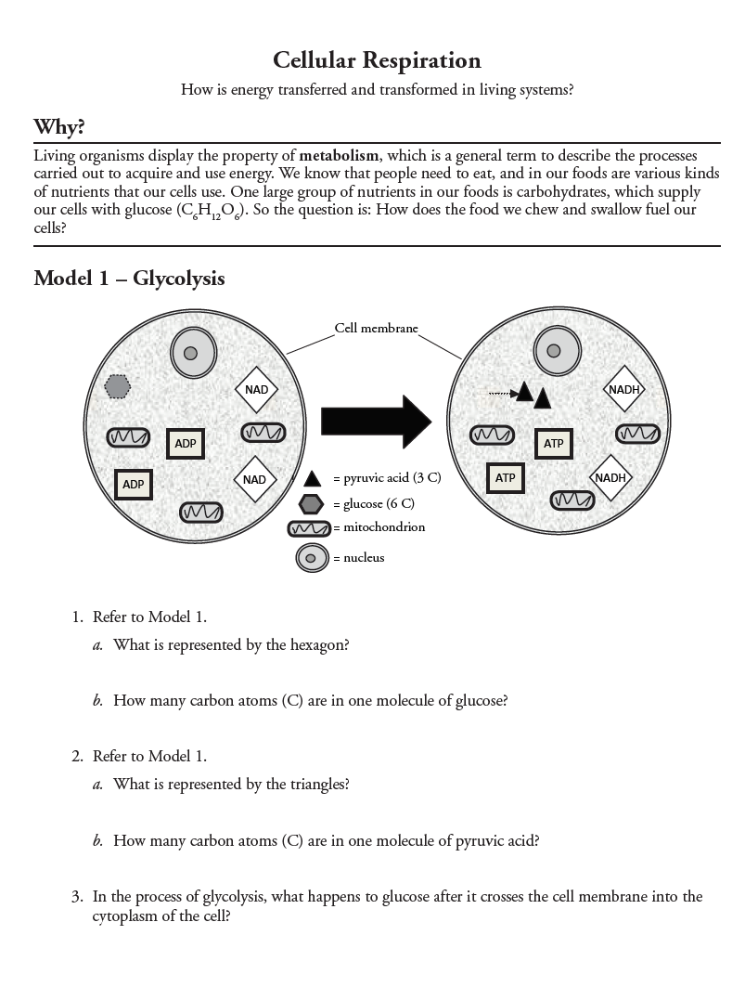
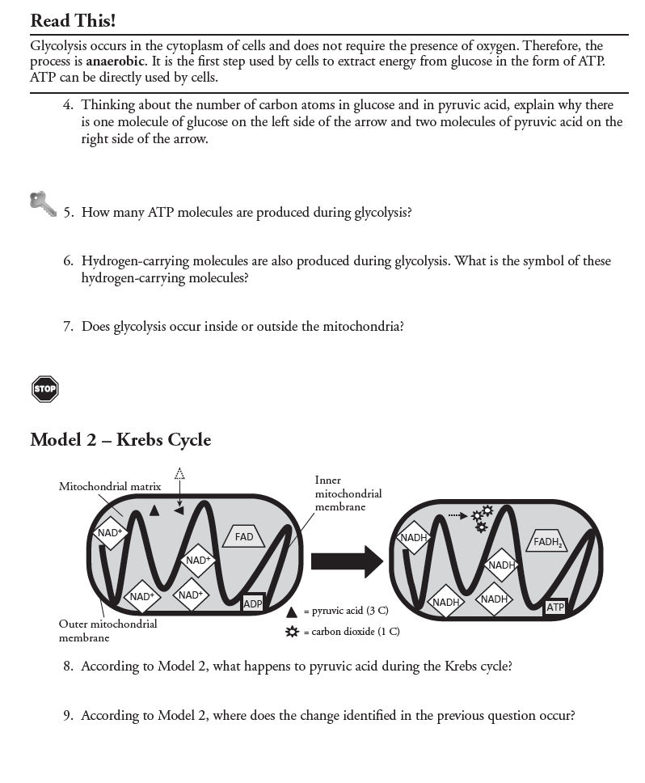

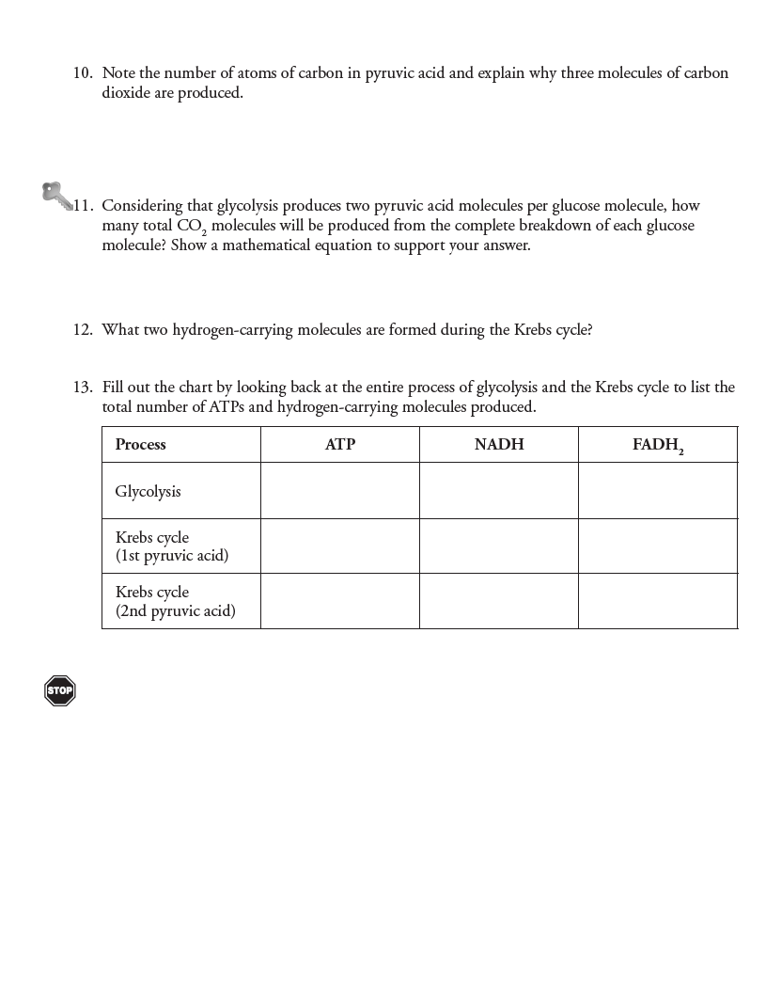

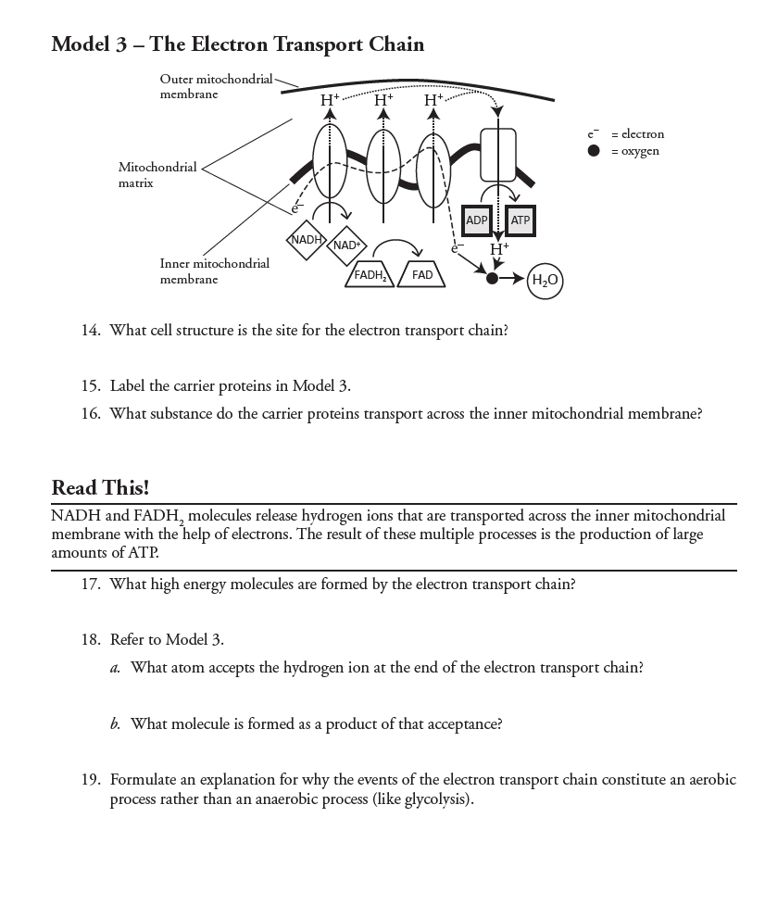

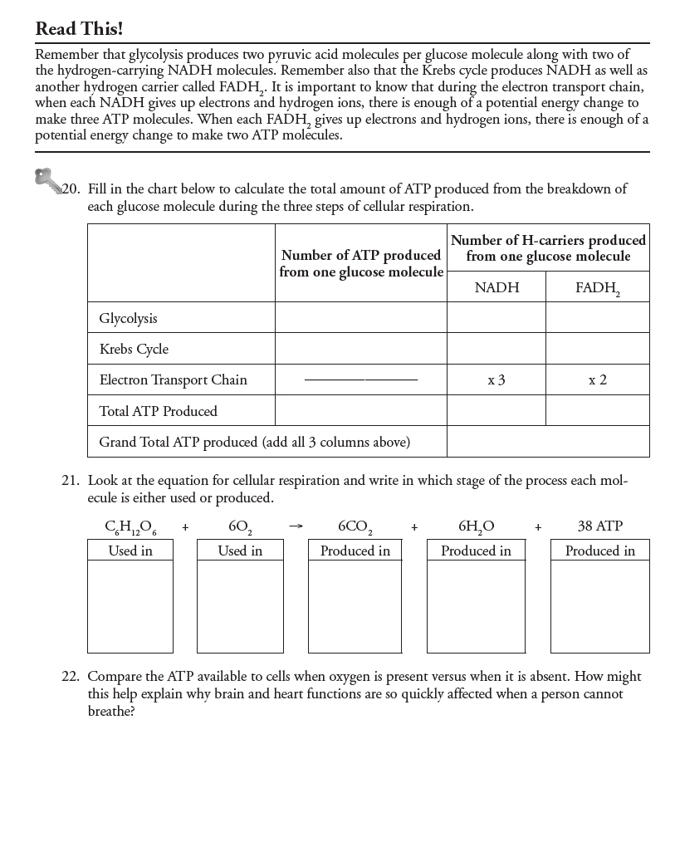

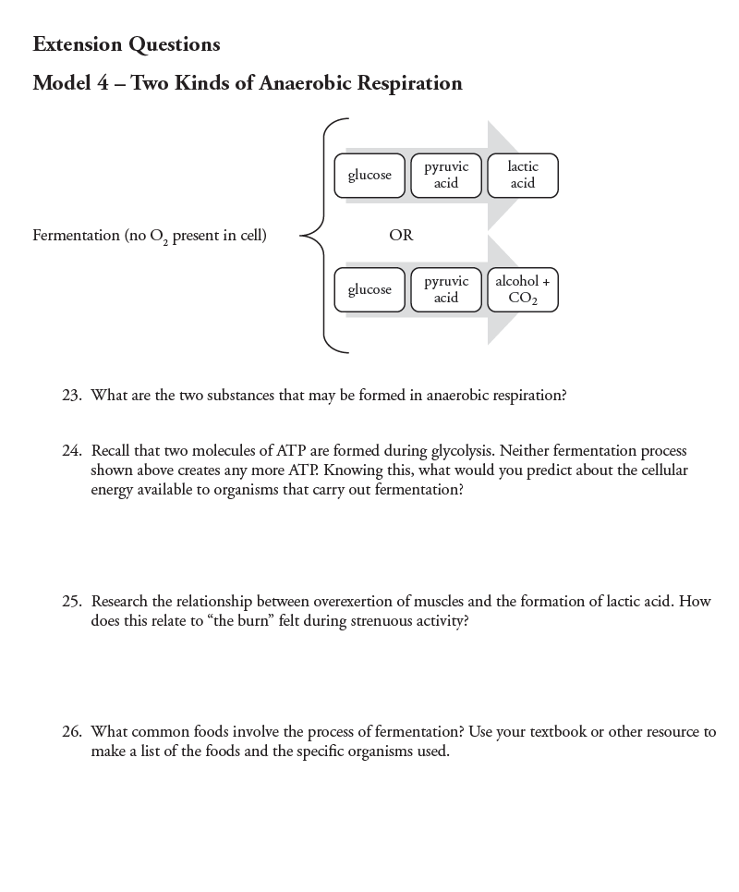

Cellular Respiration in Yeast Lab
Adapted from “Alcoholic Fermentation in Yeast Investigation” © 2009 by Dr. Jennifer Doherty and Dr. Ingrid Waldron, University of Pennsylvania Biology Department

All living cells, including the cells in your body and the cells in yeast, need energy for cellular processes such as pumping molecules into or out of the cell or synthesizing needed molecules. ATP is a special molecule which provides energy in a form that cells can use for cellular processes.

Cellular respiration is the process that cells use to transfer energy from the organic molecules in food to ATP. The following equation summarizes the chemical changes that occur in cellular respiration of the monosaccharide glucose when oxygen is available.
C₆H₁₂O₆ + 6 O₂ + light 6 CO₂ + 6 H₂O + ATP
glucose oxygen carbon wáter energy
gas dioxide gas

The chemical reactions in cellular respiration are similar to the chemical reactions when organic compounds are burned, but of course no ATP is produced. Instead energy is released in the form of light and heat. The following equation shows the chemical changes that occur when the monosaccharide glucose is burned.

C₆H₁₂O₆ + 6 O₂ 6 CO₂ + 6 H₂O + heat
glucose oxygen carbon water energy
gas dioxide gas

- What are the similarities between this equation for burning glucose and the equation for cellular respiration of glucose when oxygen is available?

- What is the difference between these equations?

Cellular respiration involves many small steps. These multiple steps allow the cell to use the energy from each glucose molecule efficiently in order to make as many ATP molecules as possible.

The first major step in cellular respiration is glycolysis 1 glucose 2 pyruvate + 2 ATP

What happens next depends on whether or not oxygen is available to the cells. When oxygen is available, cells can use the Krebs cycle and the electron transport chain to make up to 36 ATPs
2 pyruvate + 6 O₂ 6 CO₂ + 36 ATP

Cellular respiration that uses O₂ is called aerobic respiration. Most of the time, the cells in our bodies use aerobic respiration:
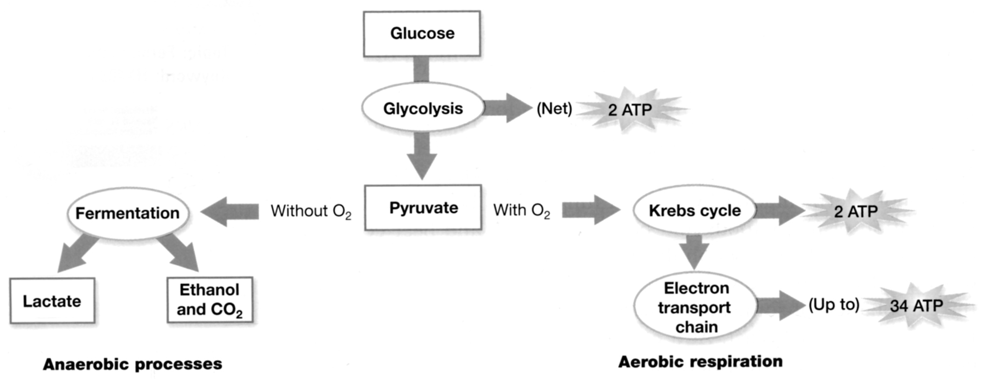

When oxygen is not available, cells use anaerobic processes to produce ATP. (The "an" in front of aerobic means “not”, so anaerobic means "not aerobic".)

Under anaerobic conditions, many cells use a process called fermentation to make ATP. There are 2 types of fermentation
lactate fermentation (e.g. in muscles when an animal exercises hard) and
alcoholic fermentation (e.g. by yeast to make wine and beer).

Fermentation has two disadvantages compared to aerobic respiration. Fermentation produces less ATP than aerobic respiration, and fermentation produces a toxic byproduct (either lactate, which becomes lactic acid, or alcohol). However, fermentation is very useful if oxygen is not available.

- Use the previous information to complete the figures below. Fill in the ovals with the appropriate molecule. On the blank lines write the name of the appropriate process. In the boxes at the bottom of the figure write how much ATP is made in each pathway.

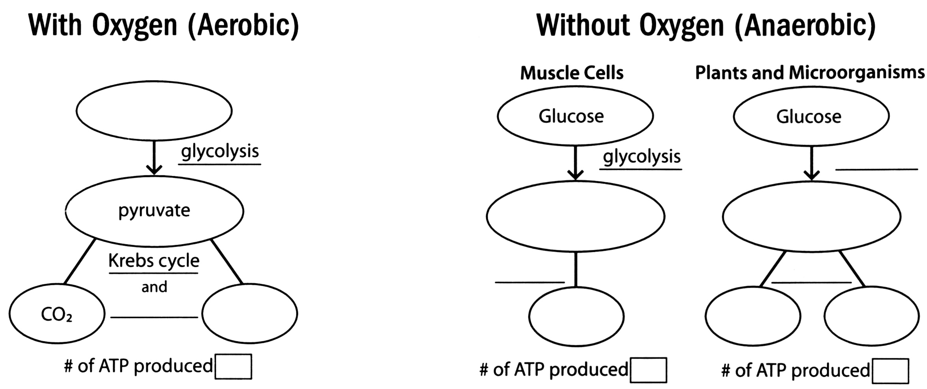

Humans use yeast every day. What is yeast? What are some common uses of yeast?

If you want to make your own bread, you can buy yeast in the grocery store. This yeast consists of little brown grains. The little brown grains of yeast may not seem to be alive, but if you put them in water with sugar, the yeast will carry out cellular respiration and grow.

- You can grow yeast in a test tube filled with water and sealed with a balloon. Do you think these growth conditions are aerobic or anaerobic?

- Under anaerobic conditions, yeast carries out alcoholic fermentation, so it produces

_________________ and ____________________. You can measure the rate of fermentation in yeast by measuring the amount of carbon dioxide gas the yeast produces. Carbon dioxide production can be measured by measuring the depth of the layer of bubbles trapped in foam on top of the yeast solution and also by observing the balloons, which catch the carbon dioxide produced and get bigger.

Part I - Sucrose Concentration
- What is sucrose?

Your first experiment will investigate the effect of sucrose concentration on the rate of cellular respiration in yeast. Yeast can convert sucrose into glucose and use it during cellular respiration.

You will design an experiment to answer the question: Does the concentration of sucrose affect the rate of cellular respiration in yeast?

Your teacher will provide you with yeast, test tubes, balloons, rulers, and four concentrations of sucrose water: 0% (plain water), 1%, 5% and 10% sucrose.

- Write a hypothesis that you will test to help you answer the research question.

- What will be the independent variable in your experiment?

- What will be the dependent variable in your experiment?

- What will be the control treatment in your experiment?

What is the purpose of this control treatment?

- The basic procedure to measure cellular respiration is:
  - Add 25 mL of the appropriate sucrose solution to each tube.
  - Add ¼ tsp of yeast to each tube.
  - Put a balloon on the top of each tube.
  - With your palm sealing the top, shake each tube until the yeast is dissolved.
  - Measure the depth of bubbles produced and observe how the balloons change after 10 minutes and 20 minutes.

Write your specific procedures here:

- Complete the first column of these data tables. Record your data below:
Sucrose treatment | Depth of CO₂ bubbles in:
 | 10 minutes | 20 minutes

Sucrose treatment | Balloon description
 | 10 minutes | 20 minutes
- Did the yeast produce different amounts of carbon dioxide with different sucrose concentrations?

Do the results match your hypothesis?

- Discuss your results with your group. What conclusions concerning the relationship between sucrose concentration and the rate of cellular respiration are supported by your results?

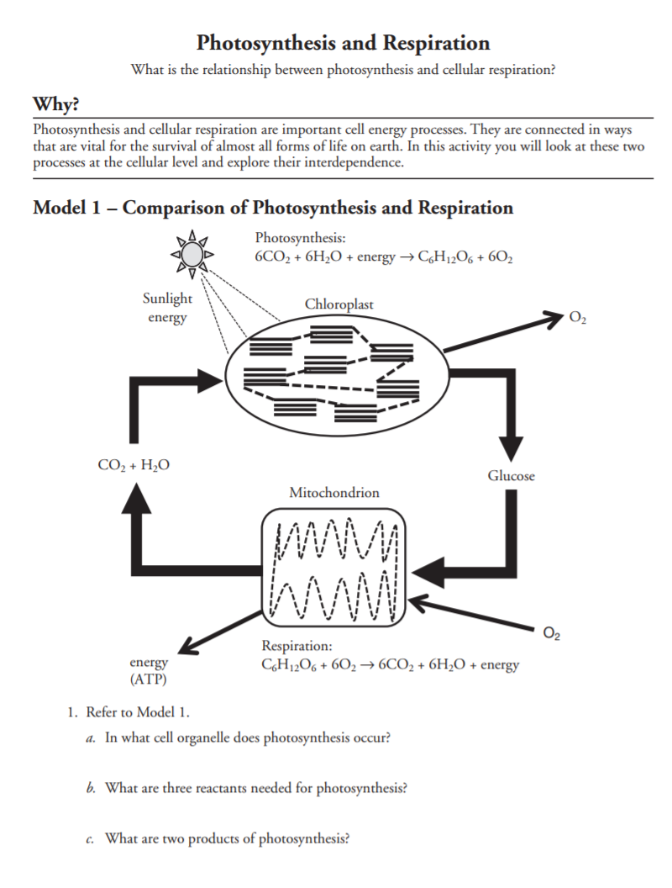
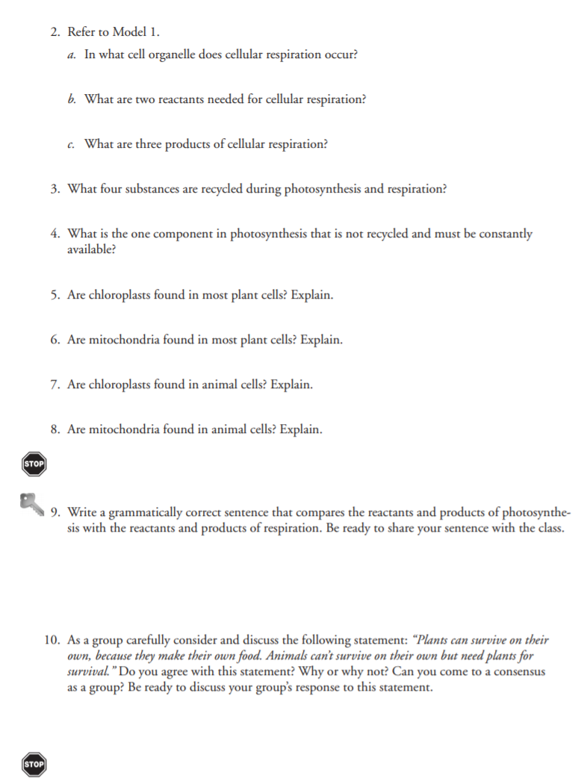
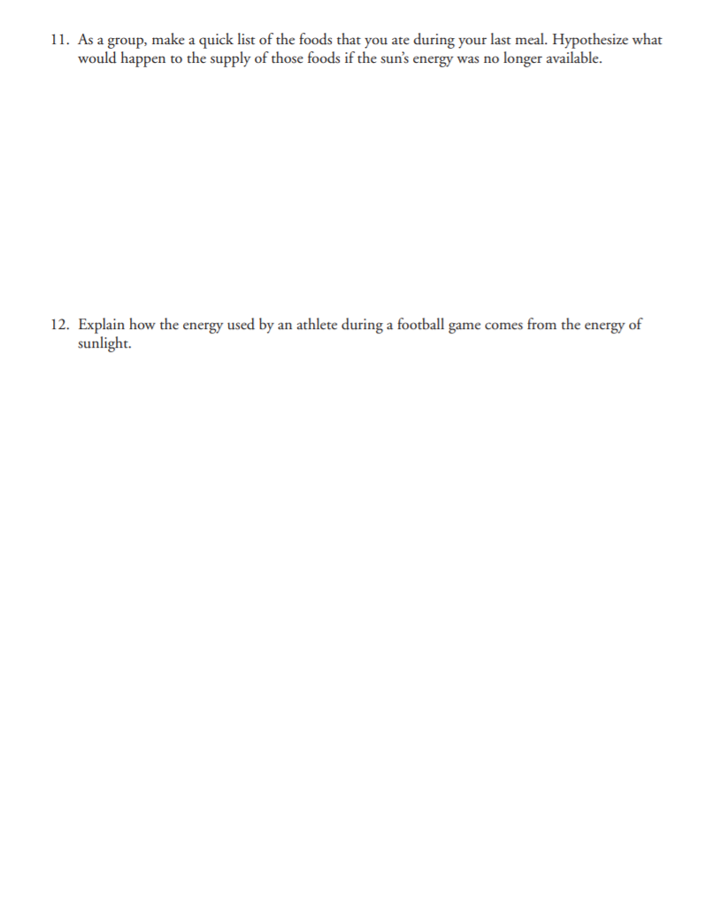
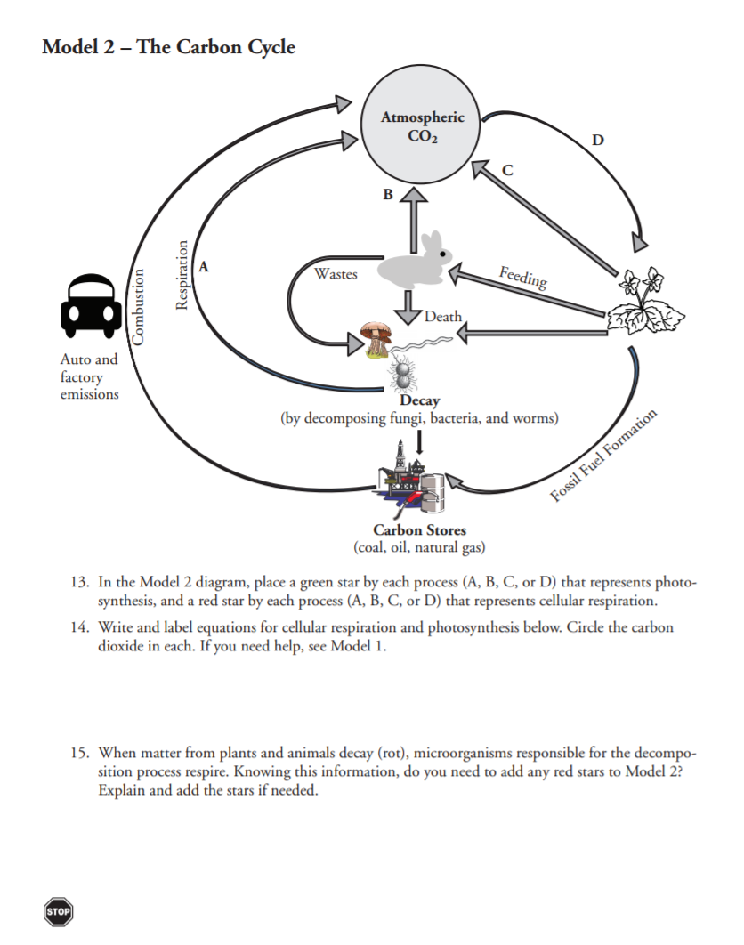
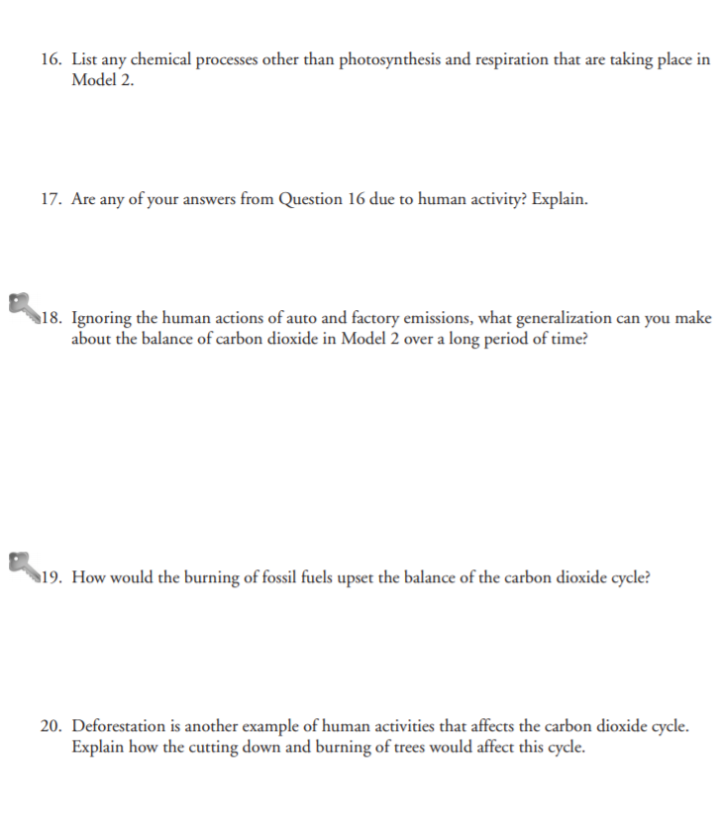

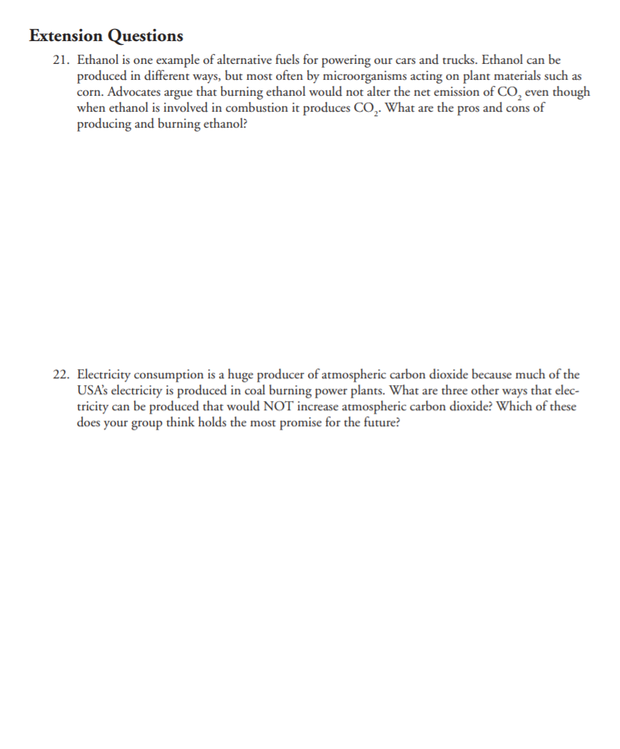

Effect of Exercise on Carbon Dioxide Production

1. Place 100 ml of bromthymol blue solution in a 125 ml flask.

2. Place a clean drinking straw in the flask so that the bottom of the straw is under the surface of the solution.

3. Have your partner begin timing one minute with a stopwatch. Blow into the flask, making sure that the straw stays in the solution. Keep blowing into the solution for one minute.

4. Put your eye goggles on.

5. Obtain a dropper bottle containing sodium hydroxide solution
CAUTION: Sodium hydroxide is corrosive to skin, eyes, and clothing.

6. Add the sodium hydroxide solution to the flask, one drop at a time, until the solution turns blue. Keep track of the number of drops of sodium hydroxide that you add. To make sure the sodium hydroxide and solution mix well, swirl the flask gently after each drop is added.

7. Rinse out the flask.

8. Repeat # 1 - 7 with your partner.

9. Rinse out the flask.

10. Add 100 ml of fresh bromthymol blue solution to the flask.

11. Exercise vigorously by running in place for one to three minutes.

12. Blow into the bromthymol blue solution through the straw for one minute.

13. Add the sodium hydroxide solution to the flask, one drop at a time, until the solution turns blue. Keep track of the number of drops of sodium hydroxide that you add. To make sure the sodium hydroxide and solution mix well, swirl the flask gently after each drop is added.

14. Repeat steps 10 - 13 with your partner.

The Effects of Exercise on Carbon Dioxide Production

 | Without Exercise | With Exercise
Trial 1
Trial 2

1. What happens when you blow into the bromthymol blue solution for one minute?

2. What does this change indicate?

3. What is the function of sodium hydroxide?

4. Did you add more sodium hydroxide to the solution in the flask before or after exercise? Why?

5. Why does the amount of carbon dioxide increase after exercise?

Review for test
Part 1:
Look at Model 1. Label the model and answer the questions below.
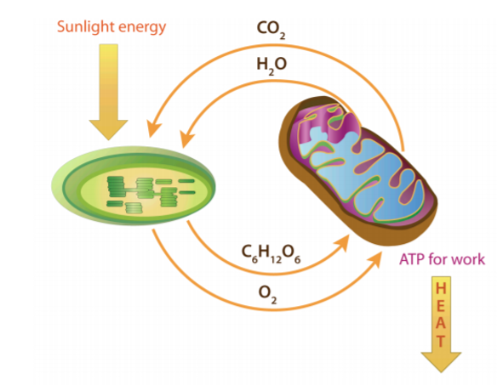

- Photosynthesis takes place in the _____________________________ of plant cells.

- During photosynthesis, _____________________________ and _____________________________ react using sunlight, to produce _____________________________ and _____________________________.

- Light energy from the _____________________________ changes to chemical energy in _____________________________.

- Cellular respiration takes place in the _____________________________ of plant and animal cells.

- _____________________________ and _____________________________ react to produce _____________________________, _____________________________ and _____________________________

- Chemical energy in _____________________________ changes to chemical energy in _____________________________.

Part 2:
Look at Model 2. Label the model and answer the questions below.

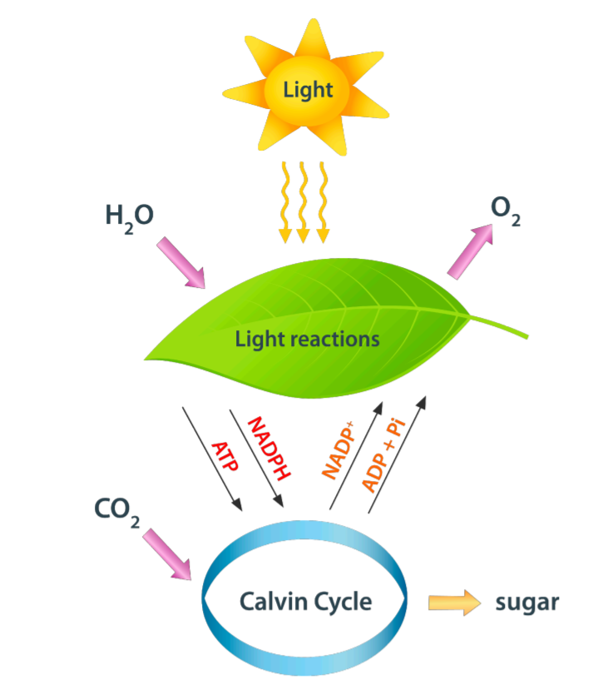

- ____________________ takes place in the chloroplast of plant cells.

- In the light reactions of photosynthesis, the energy from sunlight will split ____________________ into ____________________ atoms. These atoms will pair up and make molecules of ____________________. This is the ____________________ we breathe.

- In the Calvin Cycle, energy allows ____________________ atoms to react with ____________________ ____________________to make glucose (C₆H₁₂O₆)

Part 3:
Look at Model 1. Label the model and answer the questions below.

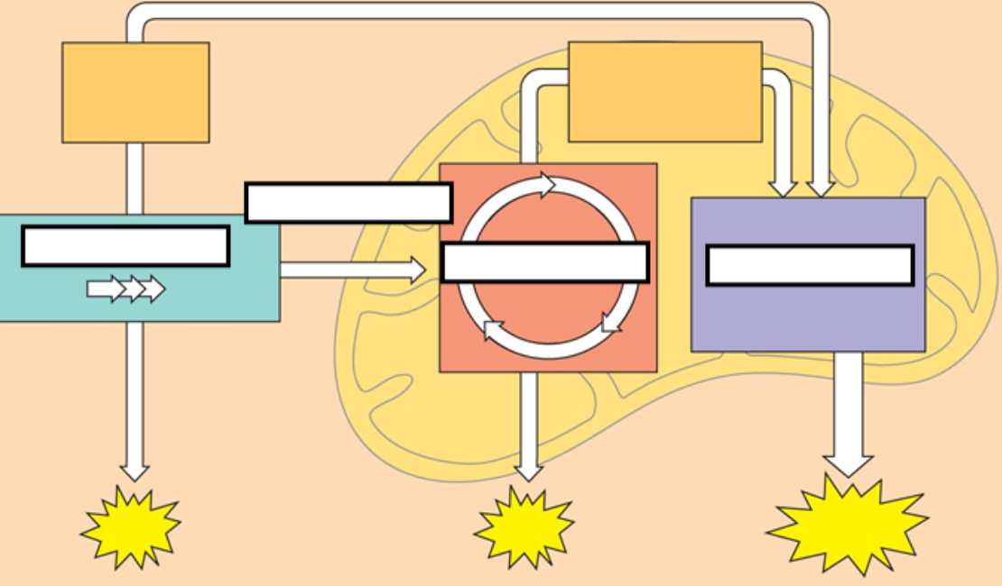

- Glycolysis takes place in the ____________________ of plant and animal cells.

- In glycolysis, glucose is broken down into 2 _________________ _________________, while 2 _________________ and 2 _________________ are also formed.

- The 2 pyruvic acid molecules move into the _________________ of the _________________ where they are broken down into 6 ________________, 2 ________________, 10 ________________ and 2 ________________.

- These molecules move to the inner membrane of the ________________, where the ________________ ________________ ________________ takes place.

- During this process, 10 NADH and 2 NADH₂ react with ________________ to produce 32 ________________ and 6 ________________.

PHOTOSYNTHESIS AND RESPIRATION SIMULATION
http://sepuplhs.org/high/sgi/teachers/photosynthesis2_sim.html

Label the diagrams and answer the questions below:

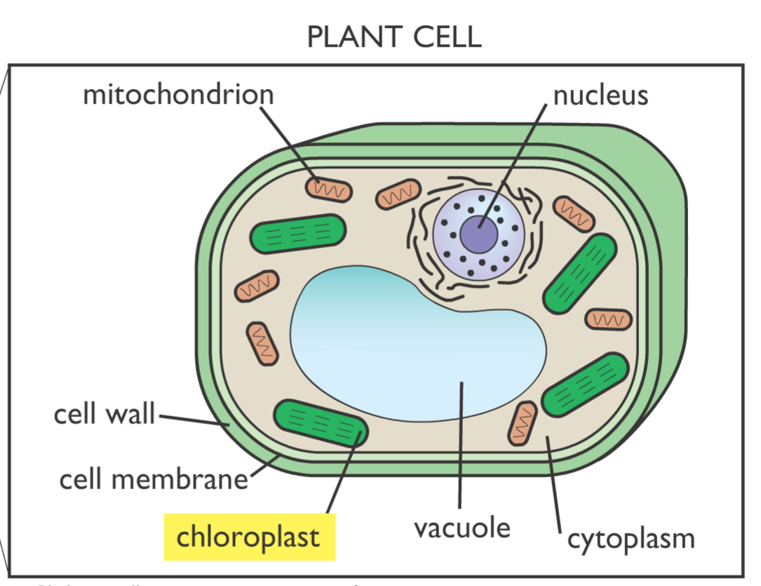

- _________________ absorb energy from sunlight.

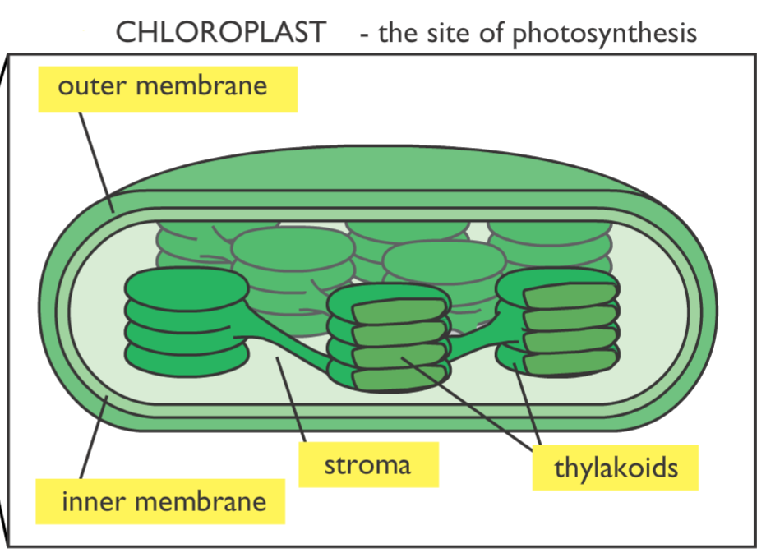

- The fluid filled space in the chloroplast is called the ____________________

- The ________________ membranes contain chlorophyll. The stacked structure greatly increases the ________________ ________________.

- The light dependent reactions take place in the ________________ ________________.

- The light dependent reactions absorb ________________ ________________ and ________________ while releasing ________________ into the environment.

- Some energy from the reactions make ________________ and ________________ ________________.

- The light independent reaction (Calvin Cycle) take place in the ________________

- Carbon dioxide combines with hydrogen ions and electrons to produce ________________

- ________________ is converted back to ADP and ________________ is converted back to NAD⁺.

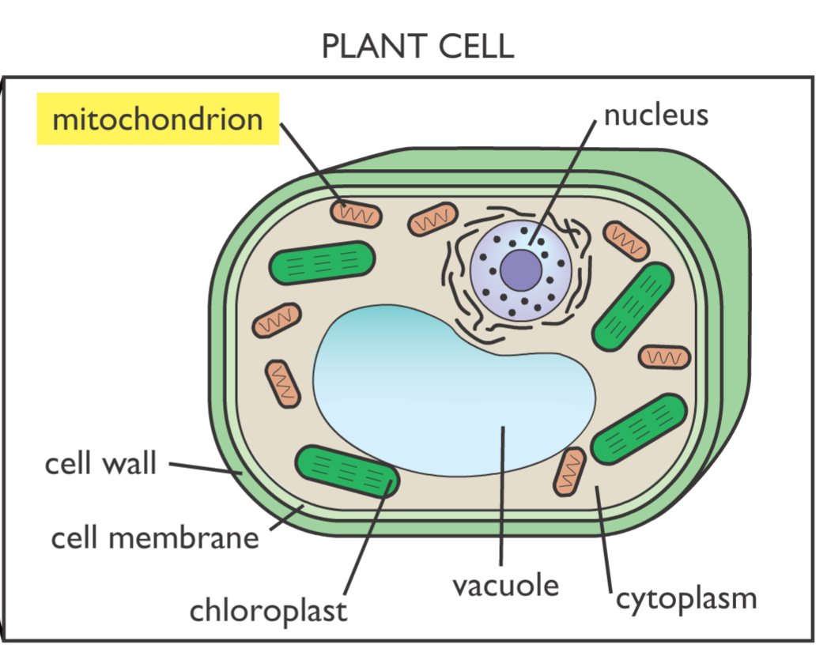

- Cellular respiration takes place in the ____________________

- Glycolysis means “___________________ ___________________ ___________________”

- Glycolysis takes place in the ___________________

- Glycolysis takes in ___________________ and produces 2 ___________________ and 2 ___________________

- Aerobic respiration takes place in the presence of ___________________.

- The 2 pyruvic acid molecules produced in glycolysis are further broken down to release large amounts of ___________________

- Aerobic respiration in the cellular respiration is broken down into the ___________________ ___________________ and the ___________________ ___________________ ___________________.

- Carbon dioxide and 2 ATP molecules are produced during ___________________.

- During the Electron Transport Chain, oxygen reacts with hydrogen to produce ___________________ and 32 ___________________ are produced.

- Cellular respiration that occurs in the absence of oxygen in called ___________________ respiration or ___________________.
Part 4:
Complete the online simulation
https://my.hrw.com/sh2/sh07_10/student/flash/virtual_investigations/hst/act/hst_act_vi.html

Read these passages from the text and answer the questions that follow.

Introduction
All living things need energy, which is defined as the ability to do work. You can often see energy at work in living things —a bird flies through the air, a firefly glows in the dark, a dog wags its tail. These are obvious ways that living things use energy, but living things constantly use energy in less obvious ways as well.

Why Living Things Need Energy

Inside every cell of all living things, energy is needed to carry out life processes. Energy is required to break down and build up molecules and to transport molecules across plasma membranes. All life’s work needs energy. A lot of energy is also simply lost to the environment as heat. The story of life is a story of energy flow —its capture, its change of form, its use for work, and its loss as heat. Energy, unlike matter, cannot be recycled, so organisms require a constant input of energy. Life runs on chemical energy. Where do living organisms get this chemical energy?

How Organisms Get Energy: Autotrophs and Heterotrophs

The chemical energy that organisms need comes from food. Food consists of organic molecules that store energy in their chemical bonds. In terms of obtaining food for energy, there are two types of organisms: autotrophs and heterotrophs.

Autotrophs

Autotrophs are organisms that make their own food. Most autotrophs use the energy in sunlight to make food in a process called photosynthesis. Only three types of organisms —plants, algae, and some bacteria —can make food through photosynthesis.

Autotrophs are also called producers. They produce food not only for themselves but for all other living things as well (which are known as consumers). This is why autotrophs form the basis of food chains.

Heterotrophs

Heterotrophs are living things that cannot make their own food. Instead, they get their food by consuming other organisms, which is why they are also called consumers. They may consume autotrophs or other heterotrophs. Heterotrophs include all animals and fungi and many single-celled organisms. What do you think would happen to consumers if all producers were to vanish from Earth?

Questions

1. What is energy? Give an example of how energy is used in a living organism.

2. Distinguish between autotrophs and heterotrophs.

3. Determine if the following are autotrophs or heterotrophs:
  - a giant redwood tree

  - a spider

  - a rose bush

  - a mushroom,

  - a blue whale.

4. How is energy used in a cell?

5. Why are autotrophs considered the basis of food chains?

- Read these passages from the text and answer the Questions that follow.
Photosynthesis Stage I: The Light Reactions
The first stage of photosynthesis is called the light reactions. During this stage, light is absorbed and transformed to chemical energy in the bonds of NADPH and ATP. You can read about this process below.

Steps of the Light Reactions

The light reactions occur in several steps, all of which take place in the thylakoid membrane.

• Step 1: Units of sunlight, called photons, strike a molecule of chlorophyll in photosystem II of the thylakoid membrane. The light energy is absorbed by two electrons (2 e−) in the chlorophyll molecule, giving them enough energy to leave the molecule.

• Step 2: At the same time, enzymes in the thylakoid membrane use light energy to split apart a water molecule. This produces:
– two electrons (2 e−). These electrons replace the two electrons that were lost from the chlorophyll molecule in Step 1.
– an atom of oxygen (O). This atom combines with another oxygen atom to produce a molecule of oxygen gas (O2), which is released as a waste product.
– two hydrogen ions (2 H+). The hydrogen ions, which are positively charged, are released inside the
membrane in the thylakoid interior space.

• Step 3: The two excited electrons from Step 1 contain a great deal of energy, so, like hot potatoes, they need something to carry them. They are carried by a series of electron-transport molecules, which make up an electron transport chain. The two electrons are passed from molecule to molecule down the chain. As this happens, their energy is captured and used to pump more hydrogen ions into the thylakoid interior space.
• Step 4: When the two electrons reach photosystem I, they are no longer excited. Their energy has been captured and used, and they need more energy. They get energy from light, which is absorbed by chlorophyll in photosystem I. Then, the two re-energized electrons pass down another electron transport chain.
• Step 5: Enzymes in the thylakoid membrane transfer the newly re-energized electrons to a compound called NADP+. Along with a hydrogen ion, this produces the energy-carrying molecule NADPH. This molecule is needed to make glucose in the Calvin cycle.
• Step 6: By now, there is a greater concentration of hydrogen ions —and positive charge —in the thylakoid interior space. This difference in concentration and charge creates what is called a chemiosmotic gradient. It causes hydrogen ions to flow back across the thylakoid membrane to the stroma, where their concentration is lower. Like water flowing through a hole in a dam, the hydrogen ions have energy as they flow down the chemiosmotic gradient. The enzyme ATP synthase acts as a channel protein and helps the ions cross the membrane. ATP synthase also uses their energy to add a phosphate group (Pi) to a molecule of ADP, producing a molecule of ATP. The energy in ATP is needed for the Calvin cycle.

Questions

1. In one sentence, describe what happens during the light reactions.

2. In which step(s) of the light reactions is sunlight absorbed?

3. Why is water “split” during the light reactions?

4. What is an electron transport chain? What is its role during these light reactions?

5. How is ATP made during the light reactions?

- Read these passages from the text and answer the questions that follow.
Cellular Respiration Stage III: Electron Transport
Electron transport is the final stage of aerobic respiration. In this stage, energy from NADH and FADH2, which result from the Krebs cycle, is transferred to ATP. Can you predict how this happens? (Hint: How does electron transport occur in photosynthesis?)

Transporting Electrons

High-energy electrons are released from NADH and FADH2, and they move along electron transport chains, like those used in photosynthesis. The electron transport chains are on the inner membrane of the mitochondrion. As the high-energy electrons are transported along the chains, some of their energy is captured. This energy is used to pump hydrogen ions (from NADH and FADH2) across the inner membrane, from the matrix into the intermembrane space.

Making ATP

The pumping of hydrogen ions across the inner membrane creates a greater concentration of the ions in the inter- membrane space than in the matrix. This chemiosmotic gradient causes the ions to flow back across the membrane into the matrix, where their concentration is lower. ATP synthase acts as a channel protein, helping the hydrogen ions cross the membrane. It also acts as an enzyme, forming ATP from ADP and inorganic phosphate. After passing through the electron-transport chain, the “spent” electrons combine with oxygen to form water. This is why oxygen is needed; in the absence of oxygen, this process cannot occur.

How Much ATP?

You have seen how the three stages of aerobic respiration use the energy in glucose to make ATP. How much ATP is produced in all three stages? Glycolysis produces 2 ATP molecules, and the Krebs cycle produces 2 more. Electron transport begins with several molecules of NADH and FADH2 from the Krebs cycle and transfers their energy into as many as 34 more ATP molecules. All told, then, up to 38 molecules of ATP can be produced from just one molecule of glucose in the process of aerobic respiration.

Questions

1. In photosynthesis, electron transport comes at the beginning of the process. Where does electron transport occur during cellular respiration?

2. What is the role of the electron transport chain in cellular respiration?

3. Why is the role of oxygen in cellular respiration?

4. Describe ATP synthase and its role.

5. Summarize how up to 38 molecules of ATP are produced for each glucose molecule.

- Read these passages from the text and answer the questions that follow.
Fermentation
An important way of making ATP without oxygen is called fermentation. It involves glycolysis but not the other two stages of aerobic respiration. Many bacteria and yeasts carry out fermentation. People use these organisms to make yogurt, bread, wine, and biofuels. Human muscle cells also use fermentation. This occurs when muscle cells cannot get oxygen fast enough to meet their energy needs through aerobic respiration.

There are two types of fermentation: lactic acid fermentation and alcoholic fermentation. Both types of are described below.

Lactic Acid Fermentation

In lactic acid fermentation, pyruvic acid from glycolysis changes to lactic acid. In the process, NAD+ forms from NADH. NAD+, in turn, lets glycolysis continue. This results in additional molecules of ATP. This type of fermentation is carried out by the bacteria in yogurt. It is also used by your own muscle cells when you work them hard and fast.

Did you ever run a race and notice that your muscles feel tired and sore afterward? This is because your muscle cells used lactic acid fermentation for energy. This causes lactic acid to build up in the muscles. It is the buildup of lactic acid that makes the muscles feel tired and sore.

Alcoholic Fermentation

In alcoholic fermentation, pyruvic acid changes to alcohol and carbon dioxide. NAD+ also forms from NADH, allowing glycolysis to continue making ATP. This type of fermentation is carried out by yeasts and some bacteria. It is used to make bread, wine, and biofuels.

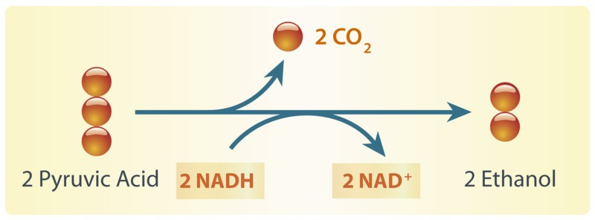

Alcoholic fermentation produces ethanol and NAD+. The NAD+ allows glycolysis to continue making ATP.

Have your parents ever put corn in the gas tank of their car? They did if they used gas containing ethanol. Ethanol is produced by alcoholic fermentation of the glucose in corn or other plants. This type of fermentation also explains why bread dough rises. Yeasts in bread dough use alcoholic fermentation and produce carbon dioxide gas. The gas forms bubbles in the dough, which cause the dough to expand. The bubbles also leave small holes in the bread after it bakes, making the bread light and fluffy.

Questions

1. What is fermentation?

2. Why is NAD+ so important in fermentation?

3. Both lactic acid fermentation and alcoholic fermentation begin with the same molecule. What is that molecule and where did it come from?

4. Why is bread light and fluffy?

5. Why do your muscles get sore after intense activity?

